For linux
HR- round
Tell me about yourself, why to hire you, strengths and weakness, time when you face conflits and how you resolve it, how to manage time in many taks, leadership moments.

Q) what is systemfs, rootfs, systemd, ioctl, procfs, tasklets, workqueue?
- 1. systemfs
systemfs is not a standard term in the Linux kernel, but it could refer to:
- A custom virtual filesystem: Some Linux distributions or embedded systems use systemfs as a virtual filesystem for system-related files.
- A user-defined filesystem: In some cases, developers create custom pseudo-filesystems in the kernel for specific purposes.
If you meant sysfs, that is a virtual filesystem (/sys/) used to expose kernel objects and device driver information to user space.
- 2. rootfs
- rootfs (Root Filesystem) is the first filesystem that the Linux kernel mounts as the root (/) during boot.
- It can be an initramfs (a temporary RAM-based filesystem) or a real filesystem like ext4, Btrfs, or JFFS2.
- In embedded systems, rootfs is often stored in flash memory or RAM.
- 3. systemd
- systemd is the modern system and service manager for Linux, responsible for booting the system and managing services (daemons).
- It replaces the older SysVinit and Upstart systems.
- It uses unit files (.service, .target, .socket, etc.) to define how services start, stop, and interact.
- 4. ioctl (Input/Output Control)
- ioctl() is a system call that allows user-space programs to send control commands to kernel drivers.
- Used for device-specific operations that can't be done using standard file operations (read, write, etc.).
- 5. procfs (Process Filesystem)
- procfs is a virtual filesystem (/proc/) that provides information about running processes and system status.
- Used for debugging, monitoring, and kernel-user communication.

Q) why floating point mode is off in kernel space?
- When a user-space process uses floating-point instruction, the kernel manages the transition from integer to floating point mode.
- Many programs don’t use floating point or fonc use it on any diven time slice and so to save the FPU regs and other FPU states takes time therefore in OS kernel many simply turn FPU off.
- In user space, if a program attempst an FPU op, the program will trap into kernel, so kernel will turn on the FPU and restore any save state that may already exist and the return to reexecute the FPU op. Before leaving the code and after execution the kernel will close turn off FPU.

Q) fopen, fclose, Open, close, etc is left to understand and write related to file openings and sys calls.
- fopen and fclose all the related calls are done at user space to access files and its related data. Here we do it when we need to senda data from user space to user space. Here we do not use kernel to do some data manipulation and it is slight faster dealing with small files.
- Opne and close does the same thing but at a kernel space. When we call this we intend that kernel will manage the things related to data transfer and manipulation and all. They both does the same thing just one uses kernel and other don’t.
Q) what is PCB which is related to struct task_struct *current?
- current->pid; currect->comm, etc.

Q) I want 4 kb memin kernel space and I am wrtiting a module and 4kb space is not available but I am using GFP_ATOMIC what will happen
- First it will try to allocate the required memory by freeing some processes which are not in use and will store that processes info outside ram or in swap memory so that when the memory is available for the processes, the system can assigne it back.
- If there are no processes which can be freed, it will not assign the memory and will return NULL, so always use a NULL condition with ATOMIC as it might not always assign memory.
- ATOMIC is like interrupts, tasklets aor other atomic contexts which does not go to sleep or wait for the free memory, if there is no free memory it will go back. IF we use KERNEL instead of ATOMIC, it will call page reclaiming or compaction to free up memory, GFP_ATOMIC does not invoke the memory allocator’s reclaim mechanisms.

Q) what do you mean by file structure in device drivers for entry points?
Q) If I register a divecie with count 1 i.e minor number 0 (only 1 device). What happens if we attach 2 devices simultaneously having this major number as it has only 1 minor number?
- If we connect 2 devices simultaneously, then it will not recognize the second device as there is no minor number available. But, if both devices tries to get the minor number then there is a chance of creating race condition.

Q) Magic number vs Major and minor number.
- The Magic Number is a unique number or character that will differentiate our set of ioctl calls from the other ioctl calls. some times the major number for the device is used here.

Q) Can we give arguments to the kernel module? If yes how?
Yes, we can pass arguments to the kernel module. We need to provide the args during the insertion of the module. You also need to add this things to the module code:
- If we want to change the name/count or anyother things in the module we need to mention them in the global space I.I below the include lib section outside of aany func.
- If we want to give a default name/count if we do not pass the arg we can do that so that it does not throw error.
- Add this “module_param(name, charp, S_IRUGO);”, here instead of name we can provide the count or the variable and also change the “charp” to “int” if it is an int data type.
- Eg:
  - #include <linux/kernel.h,module.h>
MODULE_LICENSE(“GPL”);
Char *name = “Embedded”;
Int loop=1;
Module_param(name, charp, S_IRUGO);
Module_param(loop, int , 777);

Static int __init_module(){
Printk(KERN_INFO”%s : in init\n”, __func__);
Printk(KERN_INFO”%s: loop %d\n”, __func__, loop);
For(int i=0;i<loop;i++) printk(KERN_INFO”%s: hi %s\n”, __func__, name);
Return 0;
}

Static void cleanup_modlue(){
Printk(KERN_INFO”%s: in exit”, __func__);
}

- Now when inserting the module use this cmd ”sudo insmod ./module_name name=Shivam”.
- If we pass wrong parameter we will not ne able to insteer the module and an error will pop up. But if the parameter or args is in char then it will accept the input as it is and will not throw error.
- To pass a parameter to a built in module we can do that using cmd line argument. Eg;- “module_name.paramter_name=value”.
- To provide parameters which are inserted using modprobe, we will update the “/etc/modprobe.conf” file for parameter as modprobe read this file for params.
- If we want to pass a space separated string to the name, in normal condition it will only capture and store the first word. So to splve this we will pas it in name=‘ ”stinrg to pass” ’.
- If we want to pass an array we will use “module_param_array (name, type, nump, perm)” instead “module_param”.
- There is also one param called “invbool”, this is called as inverse bool. So if true passed in args it will be consider as false and vice-versa.

Q) how do user connect with hw:
user->shell->kernel->hw
user passes the cmds to shell, if it is valid then it passes to kernel (shell does not do processing). Kernel will decide what to do with the cmds. It will decide is it for memeroy or which hw and so on.
Kernel is the brain of the system. There is only one kernel and can have multiple shells. Default shell is “bash”. There are multiple shells “csh”, “ksh”.

******************System calls
- System calls are majorly grouped into 5 categories: -
  - Process control
    - End, abort, load, execute, create process, terminate process, get process attributes, set process attributes, wait for time, wait event signal event, allocate and free memory.
  - File manipulation
    - Create file, delete file, open, close, read, write, reposition, get file attributes, set file attributes.
  - Device management
    - Request device, release device, read, write, reposition, get device attributes, set device attributes, logically attach or detach devices.
  - Information maintenance
    - Get time or date, set time or date, get system data, set system data, get process, file or device attributes, set process, file or device attributes.
  - Communications
    - Create, delete comms connection, send receive messages, transfer status info, attach or detach remote devices.

***************** multi and hyper threading
- There are 3 types of multi-threading
  - One to many – here only 1 kernel thread will run many user thread
  - One to one – here 1 thread will run 1 thread and so 4 kernel threads will run 4 user theread.
  - Many to many – here multiple kernel threads will run multiple user threads. Best model out of these 3.
- Hyperthreading or Simultaneous Mulithreading (SMT by intel)
  - Hyperthreaded systems allow their processor cores resources to become multiple lofiacal processors fro performance.
  - It enables the processor to execute 2 threads or set of inst at the same time.
  - Since hyperthreading allows 2 sreams to be executed in parallel, it is almost like having 2 separate processors working together.
  - Here if the system supports this, the core will process 2 times thread the number of cores. If we have 4 core system then it will run 8 threads parallel to each other.
- Thread cancellation: -
  - You can always at the end join the threads and end the thread but if you want to terminate in between the process there are 2 ways: -
    - Asynchronous: One thread terminates another thread immediately
    - Deferred: One thread indicates that the target is to be cancelled. The target thread will periodically check the flag and determine if it can be safely cancelled.
    - Resource allocated for the thread: Normally, the OS will take back the allocated resources. But for asynchronous cancellation, the resource may not be released. For deferred cancellation, the resource will always be released.

******************Linux kernel Architecture
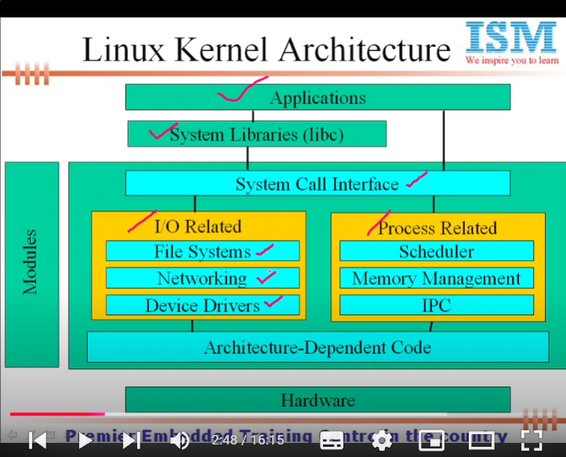
Application->Sys libs-> (modules and Arch independent code) System Call Interface-> (module) Arhiteacture-Dependent code-> Hardware

System Call Interface will have->I/O related and Process related modules;
I/O related-> File systems; Networking; Device Drivers
Process Related-> scheduler; Memory Management; IPC.

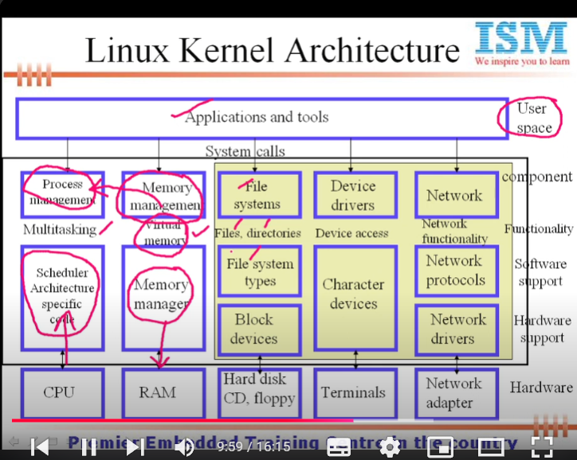

Applications and tools(user space)-> (kernel space everything else)Process management; Memory Management; File systems; Devices drivers; Network -> Scheduler Arch specific code; Memory manger; (File sys types->Block devices); char devices; (Network protocols-> Network drivers) -> CPU; RAM; Hard disk, CD, floppy; Terminals; Network adapter.
Process management is responsible for multitasking; Mem management is responsible for virtual memory; files systems is responsible for files and dirs.; Device drivers are responsible for device access; and netwok is responsible for network protocols

- Multitasking
Multitadsking systems need communication between tasks and IPC has 3 components;
- Data being shared by processes
- Mechanism to inform the task that data is available
- Mechanism to prevent tasks from interference
IPC can be achieved by:
- Pipes
  - Unamed Pipes (pipes)
Simple and flexible
It allows only related process to access.
Returns 2 discriptors to read and write
Best for implement Producer/consumer interaction among process.
Does not have user mode process synchronization facility.
Data processed in FIFO manner.
Eg:-
Int descriptor[2]
pipe(descriptor);
Descriptor[0]=3; //read in pipes
Descriptor[1]=4; //write in pipes
//STDIN=0 -> read (standard input)
//STDOUT=1->write(Std output)
//STDERR=2->error(std error)
Int write (int descriptor, struct data * snd_ptr, int size); //ptr to data to be sent
Int read (int descriptor, struct data * rcv_ptr, int size); //ptr to data to be read
Int main(){
Char *str=”hello how are you”;
Char buffer[80];
Int des[2];
Pipe(des);
Write(des[1],str,80);
Read(des[0],buffer,80);
Printf(“%s”,buffer);
}
Always close unwanted file descriptor. The program will run the same if we do not mention close, but linux has limit to number of fds open at the time. So when that linmit is reached, there may cause error.
Pipes are not automatic synchronizable. So we need to add sync method. So create a new pipe.

  - Named pipes (FIFOs)
It’s a special type of file which allows unrelated processes to communicate each other.
Best suited to implement client s=and server app
It accepts path name rateher than descriptor
We cannt open a FIFO in both read and write mode
Limit is 4096 bytes
Can use unlink like in files ops to remove FIFO

At Shell:
Eg:- pwd -> /home/user/temp
mkfifo my_fifo
echo “welcome here” > /home/user/temp/my_fifo
In programme:
int mkfifo(const cahr *filename, mode_t mode);
// filename = Nmame of the fifo; mode = permissions
Eg:-
Int open(const char *path, O_RDONLY);
Int open(const char *path, O_RDONLY|O_NONBLOCK);
Int open(const char *path, O_WRONLY);
Int open(const char *path, O_WRONLY| O_NONBLOCK);
Here if not mentioned it will consider as blocking. Means it will bock write ops if the fifo is full.
- Message queue
Easy and efficient and used bw related and unrelated process.
Provide sending block of datas( it send data in message type).
-msg queue consist of 2 parts; 1) msg no.(long int) And 2) msg(any data type)
-should create a msg structure.
Blocking and sync problems are avoided
Builtin sync
After reading the msg it deletes from the queue
Limit on size till 8192 bytes.
Eg:-
Struct msg{
Long int mtype;
Char mtext[n];
}
- Int msgget(ket_t key, int msgflag);
  - Create a msg queue or obtain an existing queue number.
  - Key-> an arbitrary number; msgflag-> IPC_PRIVATE=this queue is private to this program only , IPC_CREAT= create the msg queue if not [resent if present return the id of existing queue, IPC_EXCL= this will create queue if not present and if present throws error.
- int msgsnd(int msqid, const void *msg_ptr, size_t msg_sz, int msgflag);
  - To send the msg. the first part will decide msqid=destination, msg_ptr=source, msg_sz=size of msg, msgflag=flag.
- int msgrcv(int msqid, void *msg_ptr, size_t msg_sz, long int mtype, int msgflag);
        - same as above, mtype has 3 option; 1) mtype=0 first msg in the queue is read. 2) >0 first msg on the queue of type msg_typ is read. Egif mtype=3 it will wait till first msg with type 3 is received and then read. 3) <0 the first msg lesser or equalt to absolute mtype value is read. Eg:- mtype=5 it will read the first msg which is <=5.
        - 3 msgflag are there; 1) IPC_MOWAIT – return immidewatly if no msg of requested type is on the queue. 2) MSG_EXCEPT- used with msg type >0 to read first msg on the queue. 3) MSG_NOERROR – will not throw error if the size of data is greater than specified. It will read the first n (specified number) data.
4) After successful completion of send, msg_lrpid is set to the process ID of the calling process, msg_qnum is incremented by 1, msg_rtime is set to current time. Same with received one but msg_qnum will decrement by 1.
5) int msgctl(int msqid, int cmd, struct msqid_ds *buf) (msg control function)
a. cmd has 3 options, 1) IPC_STAT – copy info of the msg and provide the stats of that queue. 2) IPC_SET- to modify the value or parameters of the msg queue. 3) IPC_RMID – to remove the msg queue and its data structures.
6) sytems(“ipcs”) – this cmd in code will give the list of the IPCs running in the background with its data.

- Shared mem
- Best suited when need large amount of data to share.
- Allows multiple unrelated and related processes to access.
- Can read data many times and max no of shared segments used is 4096.
- No builtin sync facility.
- The shared mem is create in the heap area. Sp when shared mem is used the program stack will be divided into 4 part; code data, stack, shared mem and heap.
- Int shmget(ket_t key, size_t size, int shmflag)
- Here key means shm id number,size- is the size req, shmfalg- IPC_PRIVATE, IPC_CREAT, and IPC_EXCL.
b) void *shmat(int shmid, const void *shm_addr, int shmflag)
- we uses this func to attach the shared mem to the program. Shmid- shared mem id return by shmget(). Shm_addr – address at which mem to be attached. Shmflag – SHM_RND (shared mem round the add) and SHM_RDONLY.
c) int shmdt(void *ptr);
- to remove or detaching the shared mem.
d) int shmctl(int shmid, int cmd, struct shmid_ds *buf);
- Here shmid – shared mem id returned by shmget(); cmd – IPC_STAT, IPC_SET, and IPC_RMID; buf – modes and other fields.
e) struct shmid_ds(uid_t shm_perm.uid, uid_t shm_perm.gid, mode_t shm_perm.mode)
- .uid – effective user id; .gid – effective grp id; .mode - permissons
- Semaphores
-While creating semaphore we create array of semaphores.
- While using semaphore always remember that 1) get the semaphore 2) use the shared resources of semaphore 3) unlock the semaphore.
- Int semget(key_t key, int num_sems, int sem_flags);
  - Key - number to id the semaphore across multiple processes. Num_sem - are used to create n number of array of semaphores. Sem_flags – IPC_CREAT to create a semsphore if not present and if present return the number or key, IPC_EXCL – create the semaphore with that id, if same id sema present return error (-1).
- Int semop(int semid, struct sembuf *sem_ops, size_t num_sem_ops);
  - Smeid – is the id number; sem_ops – what operations to do on that sema like wait, release, take or signal operations. Num_sem_ops – number of ops to do on that sema.
- Struct sembuf{
Short sem_num;
Short sem_op;
Short sem_flag;
}
4) Before using the sema we need to set the semaphore properly means in sema we can make n number of threads accessing the critical sections, so we need to mention how many threads can access that sema. This is done by SETVAL line in semctl
a) semctl(int semid, int sem_num, int command, … )
b) int main(){
int sid;
union semnum semunion;
semunion.val=1;
sid=semget(1,1,IPC_CREAT|0666);
if(semctl(sid,0,SETVAL,semunion)==-1) printf(“Unable to set value”);
return 0;
}
Union senum{
Int val;
Struct semid_ds *buf;
Unsigned short int *array;
Struct seminfo *info;
}
Eg:-
Void take_sema(){
Struct sembuf semb;
Semb.sem_num =0;
Seemb.sem_op=-1;
Semb.sem_flag=SEM_UNDO;
If(semop(sid, &semb, 1)==-1) printf(“Unable to take sema”);
}
Void take_sema(){
Struct sembuf semb;
Semb.sem_num =0;
Seemb.sem_op=1;
Semb.sem_flag=SEM_UNDO;
If(semop(sid, &semb, 1)==-1) printf(“Unable to take sema”);
}
Int main(){
Sid=semget(1,1,IPC_CREAT);
Take_sema();
Critical_sections();
Release_sema();
Return 0;
}
- Signals
  - Signals are software interrupts and there are 31 unique signals starting from 1-31. No signal has number zero.
  - A set of macros whose name starts with ‘SIG’ is used as signal ids. And they have some default actions that e are abort, stop, dump, ignore, etc.
  - Signals are software signals therefore they are user space interrupts, while hardware interrupts are kernel space interrupts.
  - Signals sent to a non running process must be saved by kernel until process resumes and they can call system calls.
  - Make sure that a signal handler cant be interrupted by another signal otherwise it may lead to race conditions.
- We can raise the signal inside a code also. Here we will first write a func name(anything) sighandler1;
- Then in code we can set the required signal with the function;
- Eg;-
- Void sighandler1(int signum){
- Printf(“U are inside the sighandler1;”)
- }
- Void sighandler2(int signum){
- Printf(“U are inside the sighandler2;”)
- }
- Void siginthandlere(int signum){
- Printf(“U are inside the siginthandlere;”)
- }
- Void sigalrhandlere(int signum){
- Printf(“U are inside the siginthandlere;”)
- }

- int main(){
- Char nam[10];
- Printf(“Enter ur name: ”);
- Signal(SIGUSR1, sighandler1);
- Signal(SIGUSR2, sighandler2);
- Signal(SIGINT, siginthandlere);
- Signal(SIGALRM, sigalrhandlere);
- Alarm(5);
- Scanf(“%s”,nam);
- //blocking signal alarm;
- Sigblock(0xFFFFFFFB) //from now any alarm sig will be blocked for this code
- Alarm(5); //this will not rasie sig alarm as we have blocked it.
- If(strlen(nam)<5) raise(SIGUSR1);
- Else If(strlen(nam)<8) raise(SIGUSR2);
- }

- Here when we start the code, it will ask for name, and if we don’t give a name within 5 secs it will raise an alarm and will go to sigalr func. If “ctrl+c” is pressed sigint it will move to digint func. If nam< less than or <8 then will raise rasie respective func.
- Here we have used sigblock and masking it with 0xFFFFFFB. Here last bit B represents the respective sginal blocking. For kill it you need to mention other than B. Now even if you raise alarm or send signal to it, the sigalr will not trigger. Other method to block the signal is to use “sigprocmask”.
- To check or see which signals are in pending state, we can use “sigpending” method.

- Files
- Sockets.

########DEVICE DRIVERS
To use the device(HW) the user will create applications and that application will call system call (kernel) and that kernel will call device driver and that device driver will call device file and that device file will store the hardware values.
App -> kernel -> driver -> driver file -> hardware.
- Introdunction to DD:
  - Classes of devices
  - Statically linked driver
  - Dynamically linked drivers
  - Applications vs modules
  - Namespace pollution
  - Major and minor numbers
  - Module params: name, descriptions, variables,…
- Dynamica Mem allocation:
  - Kalloc(), kfree()
- Driver Entry points
- Driver regs and un-reg.
- Interrupt handling in driver:
a) Registering and freeing the IRQ handler
6) IOPORT
7)IOMEM
8) Driver entry points
a) Open(), close(), write(), read()
b) lseek, ioctl, capabilities
9) Race conditions
10) Interrupt lock
11) Semaphores
12) Spin locks
13) Atomic operators
14) Wait queues.

Linux Architecture
- Linux supports 5 types of files; they are 1) Ordinary files (-) 2) Pipe files (P) 3) Device files (c or b) 4) Directory(D) 5) softlink (L).
Process managemanet ->Archdependent code -> CPU
- Here The applications will call systems call and system call will call process management if we need to mange architecture dependent processes.
- Here it includes kernel code, algorithms for processes like scheduler, and so on that are arch dependent.
Memory Management -> Memory manager -> memory
- Here to work with memory management, the application will call system call and it will call MMU which is responsible for all memory related processes like virtual memory, paging (used by windows), segmentation (used by LINUX), and so on.
Filesystems -> file system types -> block devices -> Disks and CDs (1 block = 512 b)
- There are 2 types of file systems; 1) Disks based fs 2) Logical based fs. Altogether manages secondary memory like disks and CDs.
- Disk based fs are NTFS (windows), FAT (windows), ext4fs (linux).
- Logical based fs are procfs, ppu.
- If I want to get or write on disks we will use block device drivers.
Devices control -> char devices -> consoles, keyboard, etc (1 char = 1 b)
- This will take help of char DD to access it.
Networking -> Networking subsystem -> IF drivers -> network interfaces (64 kb size = 1 packet)
- This will use networking drivers.
- To exchange data we will use sockets.
Each piece of code that can be added to kernel at runtime is called a module.
To write a linux DD you need to be a root users.

Q) how to switch to root user?
-write this cmd and be a root user “su” (switch user).
- avoid infinite loops inside DD.

The entry point in any user programs has only one entry point which is main().
Every module is an entry points. So there are multiple entry points.
In system call we have lseek and in user applications it is fseek and in modules it is llseek.
In user app there is one entry point so whole code will run even we want to run a part of the code, but in modules, it has multiple entry points so it will only run that part of the code.
Since no libs are linked to modules, source file should never include usual header files.
Segmentation fault is harmless during user app development but in kernel coding kernel faults are fatal at least to the current process, even if it is not for the whole system.

Entry points in driver: functioins
- There are default 2 and minimum 2 entry points; 1) int init_module(void) and void cleanup_module(void). We can change the names of these entry point but we need to follow some process.
- To change the names of init_module and cleanup_module we will replace them with names say entry_module and exit_module. Now at the end of the module e will write these 2 lines; “module_init(entry_module)” and “module_exit(exit_module)”.

How to write a module?
- When we write a module we need to add <linux/module.h> file to for init and cleanup and to have a or add printing statements we need to add “<linux/kernel.h>” header files.
- Write a simple module (eg:- sample.c)
- Makefile concept
  - Create a file name “Makefile” and in that on the very first line write this cmd ”obj-m:=sample.o”.
- Make utility: then use the make cmd:
  - Make -C /lib/modules/$(shell uname -r)/build M=$(PWD) module.
  - This will create a module with name sample.ko
- To load the module to the kernel use : “insmod sample.ko” or “modprobe sample.ko”
- To list the number of modules in the kernel use any of this cmds:
  - “Cat /proc/modules” or “lsmod”.
  - The /proc section is one of the biggest file system in the kernel and it hold the important information related to the kernel and systems like which scheduler or modules are running, what the system is doing using which processor.
- To see the kernel buffer msg use “dmesg”.
- To unload the module use “rmmod sample”.
- To clear the kernel buffer use “dmesg -c”.

Namespace pollutions:
- Two or more drivers might use the same variable name and sometimes the same function name which causes difficulties for kernel whenever a request is invoked using that name. This will cause error and might result in calling that module. So, one should avoid doing this and have meaningful and unique name.
- The other way to avoid this issue is to use static keyword before every function and variable. This will set the variables and function scopes to local, means it will be only declare for your module.

Major and minor number:
- There are 2 ways to assign numbers to the modules or DD. They are; 1) static and 2) dynamic.
  - Static: - here the user will give the module or DD its major number and minor number by hard code that numbers.
  - Dynamic: - here we are telling kernel to dynamically assign these numbers to our module and DD.
- In kernel we will have ST (switch table) individually for char and block DDs. ST is an 2D array of all char DD where row is “Major” number. ST is nothing but a table holding info all related DD where rows are major number and cols are minor number.

Module parameters
- MODULE_PARM(variable, type)
  - Here just like int main(argc, argv[]), we can provide input to the module during run time.
  - Here variable means declaring the variable eg: a,gg,hi_h, etc and the type means data type, so i – int, h- short, l-long and s- sting.
  - Eg MODULE_PARM(a, “i”), MODULE_PARM(b,”s”); etc.
- MODULE_AUTHOR(name)
  - Just as name suggest it is for informing other who wrote this code.
  - Eg:- MODULE_AUTHOR(“Shivam Shah”)
- MODULE_DESCRIPTION(des)
  - Eg:- MODULE_DESCRIPTON(“This is for learning.”)
- MODULE_SUPPORTED_DEVICE(dev)
  - Eg:- MODULE_SUPPORTED_DEVICE(“this laptop.”)
- To get the info of the modules, use this cmd;
  - “modinfo -p module_name.o”
- For DMA usage we will use kmalloc and kfree.
  - For using kmalloc and kfree we need to add <linux/slab.h>. Here in both kmalloc and kfree, we are giving void *ptr as we do not know the data type it will work with. So after knowing, we can type cast the ptr.
  - Void *kmalloc(unsigned int size, int priority);
    - Here priority has 3 features; 1) GFP_KERNEL – this is used when we need to allocate or get kernel available space via kmalloc. If the give space is not available, the kernel will throw error; 2) GFP_USER – this is used to allocate or get user space, if the space is not available the kernel will throw error; 3) GFP_ATOMIC – this is used when we need space in kernel area and the code should not get interrupted or should throw error. If we need 4 k space and only 2 k space is available, tusing this atomic, kernel will free 2k space from other applications (it will duplicate the space and store it in other space and when freed it will again assign the memory back) and total of 4k will be assigned to that application.
  - Void kfree(void *obj)
    - This will free the space which was acquired by the module when module is removed.

Driver Entry Points
- A deriver has a collection of functions and also know as entry points. The basic entry points are:
  - Open()
    - When we give fopen call in application, it will call open().
  - Release()
    - When we give close() call in application, it will call release().
  - Llseek()
    - When we give fseek() call in application, it will call this function.
  - Read() (used for char device drivers only)
  - Write() (used for char device drivers only)
  - Strategy() (used for block device drivers only)
  - Ioctl() (very imp for char DD)
  - Poll()

How do drivers locate the entry points in the drivers?
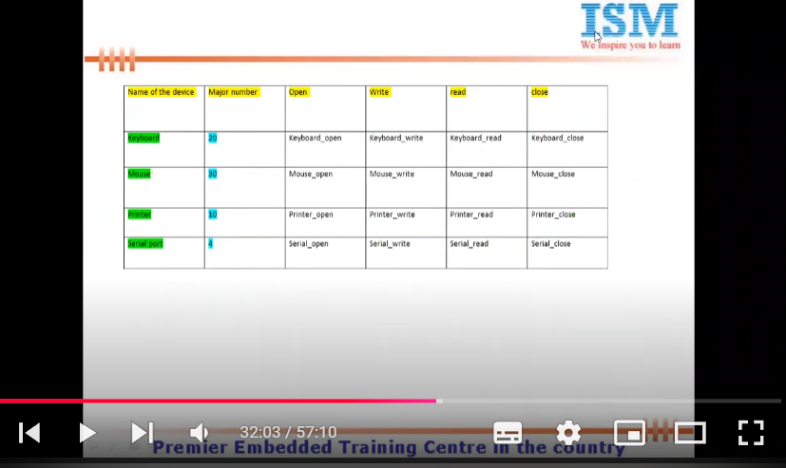
- The unix kernel maintains a set of data structures known as switch tables are used to locate driver entry points.
- The every index of the switch table signifies different device.
- The number indicated in the second col is Major device.
- The col in the switch table indicates different entry points tof that devices. That means this array will be holding the ptr address, wherein each address indicates address of each entry poiunt associated with that device.

Device registration
- To find the currect DDs with major and minor number do “cat /proc/devices” and to check the modules attached with he kernel we will use “cat /proc/modules”.
- Int init_module(){
Regidter device with major number(dynamic/static)
Return 0;
}
- Driver (module) init by calling the following func, defined in <llinux/fs.h>. Also, add <linux/types.h> for dev_t.
- To reg statically we will use “int register_chrdev_region(dev_t from, unsigned count, const char *name);”
  - Here unsigned count indicates how many same devices we need to regiseter under same major number, i.e minor number.
- To register dynamically we will use “ int alloc_chrdev_region(dev_t *dev, unsigned baseminor, unsigned count, const char *name)”;
  - Here *dev is an 32 bit int which will store the data of both Major and minor number in that variable; baseminor is there so that it will help the kernel from which minor number it should start numbering, usually 0 (but we can give other numbers like eg 1, and minor number is 3 so 1,2,3 instead of 0,1,2); count – how many devices are there ie minor number, name – module name.
  - To find the major and minor number we will use MAJOR(dev), MINOR(dev)
- To unregister we will use “unregister_chrdev_region(dev_t from, unsigned count);”
- For experimental purposes, the major number from 60-63, 120-127 and 240-254 are used as they are not used by kernel. Max range of DD are 256 (depends on the kernel range). And another 256 DDs for block. So they both can hold 256 separately.

File structure<linux/fs.h>:
- The file structure represents an open file. It is not specific to device drivers, every open file in the system has an associated struct file in kernel space.
- It is created but her kernel on open and is passed to and func that operates on the file, until the last close. After all instances of the file are closed, the kernel releases the data struc. After release that means after kernel closes the file, the info holding by the file is release by file struc still there to agin open, only data inside which was transfer is deleted.
- The file related to the specific drivers, the file contains all the entry points.
- Struct file{
Struct dentry *f_dentry;
Struct file_operations *f_op;
Unsigned int f_flags;
Mode_t f_mode;
Loff_t f_pos;
Void *private_data;
}
- Here struct dentry – it hold the info related to directory of that particular driver. Struct file_operations – this is imp as it hold and performs all the file operations like open(), close(), lseek(), etc. unsigned int f_flags – this hold which flags are there on the drivers eg:- O_RDONLY, O_WRONLY, O_NONBLOCK, etc. mode_t f_mode this hold the modes info READ, WRITE, EXECUTE PERMISSION FOR OWNER, USER AND GROUPS (eg- 777,660, etc). loof_t f_pos – this is an offset value and this is an signed int, this will help where the pointer is inside the file, eg;- it holds the offset of the data which is needed from the given pos of pointer. Void *private_data – this hold info related to driver if we give locally to that driver.
- In driver only entry points are present, no system calls. System call are present tin applications.
- Struct file_operations{
Seek, read, write, readdir, select/poll, ioctl, open, flush, release}
- For llseek – loff_t * llseek (struct file *, loff_t, int)
  - To change the current read/write pos. loff_t is a long offset.
- For read – ssize_t * read (struct file *, char *, size_t, loof_t)
  - Ssize_t – signed int, size_t – unsinged int.
  - Retrieve data from the device. A non-neg return value means byte successfully read. The value of return value will represent how many bytes it successfully read. Eg(if return 3 then 3 bytes successfully read).
  - Here 1st pos will help in which file should we read, 2nd pos – displays in which buffer we should read data from, 3rd – how much size of buffer to read, 4th – the current ptr pos (f_pos).
- For write – ssize_t * write (struct file *, const char *, size_t, loff_t *)
  - Sends data to device. If non-neg return value means bytes written successfully. The value of return value will represent how many bytes it successfully wrote. Eg(if return 3 then 3 bytes successfully written).
  - Here I pos will help in which file should we read, 2nd pos – is an array of data to be written, 3rd – how much size of data to be written, 4th – the current ptr pos (f_pos).
- For mmap –int *mmap(struct file *, stuct vm_area_struct *)
  - Used to request a mapping of device mem.
- For open – int *open (struct inode*, struct file *)
  - When device file is open, this entry point is called
- For flush – int *flush (struct file *)
  - This operation is invoked when a process closes its copy of a fd.
- For release – int *release (struct inode *, struct file *)
  - This is called when struct is released.
- For ioctl – int *ioctl(struct inode *, stuct file *, unsigned int , unsigned long);
  - This call offers a way to issue device specific cmds like formatting a track of a floppy disk, which is neither reading nor writing .
- For readdir – int *readdir (struct file *, void *, filldir_t);
  - This should be NULL for device diles, it is used for reading directories and is only usedful to fs.
- For poll – unsigned int *poll (struct file *, struct poll_table_struct *);
  - This is the back end of wo sys calls, poll and select, both used to inquire if a device is readable or writable or in some special state. Either sys call can block until a device becomes readable or writable.
  - If not mentioned, by default is assumed to be both readable and writable and in no special state. The return values is bit masked describing the status of device.
- #include <linux/kernel.h,fs.h,module.h,types.h,kdev_t.h>
Int ret;
Static dev_t mydev;
Char driver_name[]=”driver_entry_char”;

Int drv_open(struct inode *I, struct file*f){
Printf(“Open was called;”);
Return 0;
}
Ssize_t drv_write(struct file *f, const char *ubuff, size_t size, loff_t *pos){
Printk(“Write was called;”)
Return 0;
}
Ssize_t drv_read(struct file *f, char *ubuff, size_t size, loff_t *pos){
Printk(“read was called”);
Return 0;
}
Int drv_close(struct inode *I, struct file *f){
Printk(“close was called”);
Return 0;
}

Struct file_operatoins fops={
Open:drv_open;
Close:drv_close;
Read:drv_read;
Write:drv_write;
}

Int init_module(){
Printk(loading the module);
Ret = alloc_chrdev_region(&mydev,0,1,driver_name);
If (ret<0) return -1;
}
Void cleanup_module(){
Print(“unloading the module”);
}

- Here we can change the names of open, read ,etc but we need to declare them as did in struc fops so that kernel knows that these are the entry points.
- So when we load and unload only init and cleanup func are called, so to call the open, read we need to call them from application.
- Here is the user application

#include <stdio.h, fcntl.h>
Int main(){
Int fd;
Char buf[10];
Fd=open(“ism_device”, O_RDWR); //ism_device is a device file.
Write(fd, “hello”, 5);
Read(fd, buf, sizeof(buf));
Printf(“data received: %s”, buf);
Close(fd);
Return 0;
}

How to create a device file:
- Use this cmd “mknod /dev/device_name c 254 0”. If block file then replace c with b.
Interrupt handling
- CPU can handle 16 (0-15) IRQs lines. So we need to see which IRQ lines are not used by CPUs.
- Interrupts are identified by an unsigned one byte int number called vector.
- The vector ranges from 0 to 255.
- The first 32 (0-31) vectors are exceptions and non-maskable interrupts (non-mask means cannot be ignored). The range from 32-47 are assigned to maskable interrupts. The last range from 48 -255 is used to identify software interrupts; eg – for this interrupt 128(0x80 assembly instructions) which is used to implement system call.
- Our range is from 32-47, we can also call it maskable IRQs 0-15. So when we say 32 i.e 0 or when we say 0 then understand 32.
- To use interrupts in DDs we will use <linumx/sched.h>.
  - Int request_irq( Unsigned int irq, void *handler(int, void*, struct pt_regs *), unsigned long flags, const char *dev_name, void *dev_id);
    - Here int request irq will request an irq line from CPU from 0-15, and store it unsigned int irq. So, we will first see that irq table from “cat /proc/interrupts” (this will list all the 0-15 irq line which are being used.) from this we will select the lines which are not used by CPU and assigned it to int irq manually.
    - Void *handle- will handle what to do with that interrupt.
    - Long flags- there are 3 flags, 1)SA_INTERRUPT - fast (normal interrupt) 2) SA_SHARED- Sharable (shared interrupt with other device) 3) 0 – neither both.
    - Dev_name – device fs name
    - Dev_id – if the interrupts is successfully handled just assigned an id of it and store it in the dev_id format by kernel.
  - Void free_irq(unsigned int irq, void *dev_id)
    - Unsigned int irq – give the line number.
    - Dev_id – when it is a sharable irq then provide the device id else if it is a fast pass NULL.
- Eg;-
# include <linux/ kernel.h, module.h, ioport.h, sched.h>
Char driver_name[]=”driver_irq”;
Int irq_no=3;
Unsigned int major_no;

Void ISR(int irq, void *dev_id, struct pt_regs *s){
Printk(“ISR raised……………..”);
}
Int init_module(){
Printk(“Loading the module”);
If(request_irq(irq_no, ISR, 0 driver_name, NULL)!=0) printk(“Reg of %d IQR failed”, irq_no);
Else printk(“Reg of %d IRQ number susseccfull”, irq_no);
Return 0;
}
Void cleanup_module(){
Printk(“Unloading the module”);
Free_irq(irq_no, NULL);
}

- IMPORTANT PIONTS TO BE REMEMBER:-
  - Make sure that ISR is very short so that processor releases the processor for other tasks.
  - Best is, ISR can do only the time-critical comms with hardware with disable the interrupt and use the tasklet to perform most actual data transfer.
  - The tasklet is adv feature in the linux kernel, which will do certain ops related to the interrupts during the safe time. It is the software interrupt and it can be interrupted by other interrupts.

I/O PORTS:
- Some part of the memory is assigned for IO devices and some for memory devices. The devices can use both of them. If it uses IO ports then it is called IO mapped and if mem then called mem map devices.
- The following 3 funcs are actually macros, and declared in <linux/ioport.h>
  - Int check_region(unsigned long form, unsingned long extent);
    - First the device to use IO region it need s to make sure that that much mem is available or not. So we will use check_region func to see if the space is available or not.
    - So “form” is the starting point and “exten” will be the ending point of the region in which the space we needed to check and assign.
  - Struct resource *request_region(unsigned long fomr, unsigned long extent, const char *name);
    - If there is sufficient space then it will ask for space in that region.
    - Name is the device name.
  - Void release_region(unsigned long form, unsigned long extent);
    - To release the mem of that region.
- These funcs are used to reg and release I/O ports.
- “cat /proc/ioports” will show the list of ports used by installed devices.

# include <linux/ kernel.h, module.h, ioport.h, sched.h>
Char driver_name[]=”driverio”;

Int init_module(){
Printk(“Loading the module”);
If(check_region(0x0e0, 8)!= 0) printk(“IO reg is not free”);
Else request_region(0x0e0, 8, driver_name);
Return 0;
}
Void cleanup_module(){
Printk(“Unloading the module”);
Release_region(0x0e0,8);
}

I/O MEMORY:
- Same as I/O but in mem region.
- “cat /proc/iomem”.
- Also 3 func with same name and variables just add mem in b/w; 1) int check_mem_region, 2) struct resource *request_mem_region 3) void release_mem_region.
IOCTL (Input Output Control) <linux/ioctl.h>:
- It is an entry point. In addition to reading and writing the device, is the ability to perform various types of hardware control via DD. Control ops are usually supported via the ioctl method.
- It enables user to set the terminal baud rates, rewind tapes on a tape driver, perform network ops such as setting network address and changing various drive settings.
- It is a device specific entry point.
- Every device has its own ioctl cmds with four bits fields namely type, number, direction and size.
- Type- it ispecifies the magic number, for our device we choose ‘k’ as a magic number. It is a 8-bit number, so k ranges from 0-255 i.e the system can work with 256 different devices. The full list of magic number can be seen in Documentation/ioctl-number.txt file. The Magic Number is a unique number or character that will differentiate our set of ioctl calls from the other ioctl calls. some times the major number for the device is used here.
- Number – it identifies the sequential number to distinguish ioctls from each other. It also identifies how many ops aer done by that device. Remember all the ops should be in sequential manner like if device ahould have number from 0-33 or 11-20, and so on. It should never be random like 10-13-14-17-20 instead it should be 10 to all way to 20.
- Direction – it identifies the direction between the devices, in which direction and what it is doing.
  - Different direction fields are denoted by;
  - _IO – ioctl with no parameter.
  - _IOW – with write parameters (copy_from_user). Kernel reads data from user space.
  - _IOR – read params(copy_to_user), kernel write data to user space.
  - _IOWR – both read and write.
- Size – how much size it is working with, like what is the reading/ writing size, etc.
- Suppose all the magic numbers are already assigned i.e all 0-255 are being used, we can still use any magic number and make suer that at least one variable from type, number, direction or size; it is different from the other device using same magic number. Usually the number field is always different between devices which has same magic number.
- (User) The ioctl func call in user space corresponds to following prototype:-
  - Int ioctl(int fd, int cmd, char *argp);
- (Module/system call) The ioctl driver method, on the other hand, receives its args according to this declaration. This is the entry point in module.
  - Int * ioctl (struct inode *inode, struct file *filp, unsigned int cmd, unsigned long arg);
- Eg:- we can use it as macro
  - #define "ioctl name" __IOX("magic number","command number","argument type")
  - #define WR_VALUE _IOW('a','a',int32_t*)
  - #define RD_VALUE _IOR('a','b',int32_t*)
  - #define MAGIC “k”
  - #define MY_CMD1 _IO(MAGIC,1)
  - #define MY_CMD2 _IOR(MAGIC, 2, int *)
Static long char_ioctl(struct file *filp, char __user *buf, size_t len, loof_t *off){
Switch(cmd){
Case WR_VALUE:
Copy_from_user(&val,(int32_t*)arg, sizeof(val));
Printk(KERN_INFO”val = %d\n”, val);
Break;
Case RD_VALUE:
Copy_to_user((int32_t *)arg,&val, sizeof(val)):
Break;
}
Return0;
}
- To use it in drivers with multiple CMDs and we need to assing which one to select through argument passing, we will use switch cases. If MY_CMD1 then this, if MY_CMD2 sitch to this etc.
- The ioclt implementations consist of a switch statement that selects the correct behacior according to the cmd args.
- Different cmds hace different numberic values, which are usually given symbolic names to simplify coding.
- The symbolic name is assigned by a preprocessor definitions and custom drivers usually declare such symbols in their own header files.
- User programs must of course, include that header files as well to have access to those symbols.
- In order to get or put data to a device either we can make use od copy_to_user or copy_from_user funcs. But if we access a single vatiabe, then put_user or get_user func is more appropriate and the execution of these funcs are faster.
- Put_user(datum, pointer):- this function sends the datum to user to space which is stored in the ptr. The size of the data transfer depends on the tupe of the pre ars.
- Get_user(datum,pointer):- opposite to put_user.
- These put_user and get_user arer defined in <asm/uaccess.h> file. On the success, these funcs return 0 else EFAULT on error.

Procfs in Device Drivers:
- Procfs can act as a bridge connecting the user space and ether kernel space. User space program can use the proc files to read the info exported by the kernel.
- Every entry in the procfs provides some info from the kernel. For eg “cat /proc/meminfo” gives you the info anbout mem used in the system.
- There can be two kinds of proc entry:
  - An entry that can read data from the kernel space.
  - An entry that can reads as well as writes data into and from kernel space.
- Creating procfs entry.
- Writing the procfs.
- In DD we write procfs same as file structure and its ops. We will declare the open, release, write, open, etc as proc_open, proc_release and so on and we also need to declare the file structure same as normal one if we change the names of the module.
- While both ioctl and the standard file operations can be used to interact with a device driver, procfs is often added to Linux device drivers because it provides a more convenient and structured way to access detailed information about the device's internal state, allowing for easier debugging and monitoring without requiring a separate user-space application to issue specific ioctl commands; essentially acting as a dynamic, real-time view into the device's operation through a file system interface.

Capabilities and Restriction Ops <sys/sched.h> and <linux/capability.h>:-
- Unix system have traditionally restricted privileged ops to superuser accounts.
- The linux kernel provides a more flexible system called capabilities.
- Before performing a privilieged ops, a device driver should check that the calling peocess has the appropriate capabilities with the capable function.
- Int capable (int capability):
  - CAP_DAC_OVERRIDE
  - CAP_NET_ADMIN
  - CAP_SYS_MODULE
  - CAP_SYS_RAWIO
  - CAP_SYS_ADMIN
  - CAP_SYS_TTY_CONFIG
  - CAP_DAC_OVERRIDE
  - CAP_NET_ADMIN
  - CAP_SYS_MODULE
- Eg:-
  - If(!capable (CAP_SYS_ADMIN)) return -EPERM;

Llseek:
- When we try to read the data after writing the data to the driver file, we get garbage value because the file pointer is now pointing to the last bit which it wrote, so while reading it will read the next bits, so will read garbage value.
- So to solve this use llseek to make the pointer pas move back the size of buf writing and start the read and again readjust the pointer to point the last bit.
- In user space the use of lseek:
Loff_t scull_llseek (struct file *filp, loff_t off, int whence){
Loff_t newpos;
Switch(whence){
Case SEEK_SET:
Newpos = off; break;
Case SEEK_SET:
Newpos = filp->pos + off; break;
Case SEEK_SET:
Newpos =device_size + off; break;
Default:
Return -EINVAL;
}
If (newpos<0) return -EINVAL;
Filp->f_pos = newpos;
Return newpos;
}

- In kernel or module or driver space, llseek use:
Loff_t drv_lseek_llseek (struct file *f, loff_t off, int whence){
Loff_t newpos;
Switch(whence){
Case 0:
Newpos = off; break;
Case 1:
Newpos = filp->pos + off; break;
Case 2:
Newpos =device_size + off; break;
}
If (newpos<0) return -EINVAL;
Filp->f_pos = newpos;
Return newpos;
}

//and we will update the file struct declaration and the rest of the code
- #include <linux/kernel.h,fs.h,module.h,types.h,kdev_t.h>
Int ret;
Static dev_t mydev;
Char driver_name[]=”driver_entry_char”;

Int drv_open(struct inode *I, struct file*f){
Printf(“Open was called;”);
Return 0;
}
Ssize_t drv_write(struct file *f, const char *ubuff, size_t size, loff_t *pos){
Printk(“Write was called;”)
Copy_from_user(driver_buff, ubuff, size);
Printk(“Before file pointer = %d”, f->f_pos);
f->f_pos = f->f_pos + size -1;
printk(“After writing file pointer = %d”, f->f_pos);
printk(“Data copied from user-space: %s”, driver_buff);
Return 0;
}
Ssize_t drv_read(struct file *f, char *ubuff, size_t size, loff_t *pos){
Printk(“read was called”);
Copy_to_user(ubuff, driver_buff + f->f_pos, size);
printk(“After reading file pointer = %d”, f->f_pos);
Return 0;
}
Int drv_close(struct inode *I, struct file *f){
Printk(“close was called”);
Return 0;
}

Struct file_operatoins fops={
Open:drv_open,
Close:drv_close,
Read:drv_read,
Write:drv_write,
Llseek:drv_lseek,
}

Int init_module(){
Printk(loading the module);
Ret = alloc_chrdev_region(&mydev,0,1,driver_name);
If (ret<0) return -1;
}
Void cleanup_module(){
Print(“unloading the module”);
}

- User app to read and write from buffer;
#include <stdio.h>, <fcntl.h>

Int main(){
Int fd, num;
Char buf[30];
Fd = open(“lseek_123”, O_RDWR);
Write(fd, “Hello world”, 11);
Lseek(fd,6,SEEK_SET);
Read(fd,buf,sizeof(buf));
Printf(“data received from kernel space: %s”, buf);
Close(fd);
Return 0;
}

Creating driver file in device driver:
- To create a driver file we can use 2 methods
  - To create a driver file using “mknod /dev/driver -c M m”
  - We can also create a deriver file in the DD module so that we need not need to create a separate file.
Driver module**
Static dev_t my_device_nr;
Static struct class *my_class;
Static struct cdev my_device;

#define DRIVER_NAME “dummydriver”;
#define DRIVER_CALSS “MyModuleClass”

…
Static int __init ModuleInit(void){
Int retval;
Printk(“driver init”);

//allocates a device nr
If(alloc_chrdev_regine(&my_device_nr, 0 ,1 , DRIVER_NAME)<0) return -1;
Printk(M: %d, m: %d), my_device_nr>>20, my_device_nr && 0xfffff);

// create device class
If(my_class = class_create(THIS_MODULE, DRIVER_CLASS)==NULL) goto classerror;
//crete device file
If (device_create(my_class,NULL, my_device_nr, NULL, DRIVER_NAME)==NULL) goto fileerror;
// init device file
Cdev_init(&my_device, &fops);
//reg to kernel
If(cdev_add(&my_device, my_device_nr,1) == -1) got adderror;
Return 0;
Adderror:
Device_deestory(my_class, my_device_nr);
Fileerror:
Class_destroy(my_class);
Return -1;
Classerror:
Unregister_chrdev(my_device_nr, DRIVER_NAME);
Return -1;
}
Static void __exit ModuelExit(void){
Cdev_del(&my_device);
Device_destroy(my_class, my_device_nr);
Class_destroy(my_class);
Unregister_chrdev(my_device_nr, DRIVER_NAME);
Printk(“Successful unloading”);
}
- Ideally in kernel coding goto should not be used, but for DD it’s better to use it.

GPIO DD:
#include <linux/module.h>
#include <linux/init.h>
#include <linux/fs.h>
#include <linux/cdev.h>
#include <linux/uaccess.h>
#include <linux/gpio.h>

/* Meta Information */
MODULE_LICENSE("GPL");
MODULE_AUTHOR("Johannes 4 GNU/Linux");
MODULE_DESCRIPTION("A simple gpio driver for setting a LED and reading a button");

/* Variables for device and device class */
static dev_t my_device_nr;
static struct class *my_class;
static struct cdev my_device;

#define DRIVER_NAME "my_gpio_driver"
#define DRIVER_CLASS "MyModuleClass"

/**
* @brief Read data out of the buffer
*/
static ssize_t driver_read(struct file *File, char *user_buffer, size_t count, loff_t *offs) {
int to_copy, not_copied, delta;
char tmp[3] = " \n";

/* Get amount of data to copy */
to_copy = min(count, sizeof(tmp));

/* Read value of button */
printk("Value of button: %d\n", gpio_get_value(17));
tmp[0] = gpio_get_value(17) + '0';

/* Copy data to user */
not_copied = copy_to_user(user_buffer, &tmp, to_copy);

/* Calculate data */
delta = to_copy - not_copied;

return delta;
}

/**
* @brief Write data to buffer
*/
static ssize_t driver_write(struct file *File, const char *user_buffer, size_t count, loff_t *offs) {
int to_copy, not_copied, delta;
char value;

/* Get amount of data to copy */
to_copy = min(count, sizeof(value));

/* Copy data to user */
not_copied = copy_from_user(&value, user_buffer, to_copy);

/* Setting the LED */
switch(value) {
case '0':
gpio_set_value(4, 0);
break;
case '1':
gpio_set_value(4, 1);
break;
default:
printk("Invalid Input!\n");
break;
}

/* Calculate data */
delta = to_copy - not_copied;

return delta;
}

/**
* @brief This function is called, when the device file is opened
*/
static int driver_open(struct inode *device_file, struct file *instance) {
printk("dev_nr - open was called!\n");
return 0;
}

/**
* @brief This function is called, when the device file is opened
*/
static int driver_close(struct inode *device_file, struct file *instance) {
printk("dev_nr - close was called!\n");
return 0;
}

static struct file_operations fops = {
.owner = THIS_MODULE,
.open = driver_open,
.release = driver_close,
.read = driver_read,
.write = driver_write
};

/**
* @brief This function is called, when the module is loaded into the kernel
*/
static int __init ModuleInit(void) {
printk("Hello, Kernel!\n");

/* Allocate a device nr */
if( alloc_chrdev_region(&my_device_nr, 0, 1, DRIVER_NAME) < 0) {
printk("Device Nr. could not be allocated!\n");
return -1;
}
printk("read_write - Device Nr. Major: %d, Minor: %d was registered!\n", my_device_nr >> 20, my_device_nr && 0xfffff);

/* Create device class */
if((my_class = class_create(THIS_MODULE, DRIVER_CLASS)) == NULL) {
printk("Device class can not be created!\n");
goto ClassError;
}

/* create device file */
if(device_create(my_class, NULL, my_device_nr, NULL, DRIVER_NAME) == NULL) {
printk("Can not create device file!\n");
goto FileError;
}

/* Initialize device file */
cdev_init(&my_device, &fops);

/* Regisering device to kernel */
if(cdev_add(&my_device, my_device_nr, 1) == -1) {
printk("Registering of device to kernel failed!\n");
goto AddError;
}

/* GPIO 4 init */
if(gpio_request(4, "rpi-gpio-4")) {
printk("Can not allocate GPIO 4\n");
goto AddError;
}

/* Set GPIO 4 direction */
if(gpio_direction_output(4, 0)) {
printk("Can not set GPIO 4 to output!\n");
goto Gpio4Error;
}

/* GPIO 17 init */
if(gpio_request(17, "rpi-gpio-17")) {
printk("Can not allocate GPIO 17\n");
goto Gpio4Error;
}

/* Set GPIO 17 direction */
if(gpio_direction_input(17)) {
printk("Can not set GPIO 17 to input!\n");
goto Gpio17Error;
}

return 0;
Gpio17Error:
gpio_free(17);
Gpio4Error:
gpio_free(4);
AddError:
device_destroy(my_class, my_device_nr);
FileError:
class_destroy(my_class);
ClassError:
unregister_chrdev_region(my_device_nr, 1);
return -1;
}

/**
* @brief This function is called, when the module is removed from the kernel
*/
static void __exit ModuleExit(void) {
gpio_set_value(4, 0);
gpio_free(17);
gpio_free(4);
cdev_del(&my_device);
device_destroy(my_class, my_device_nr);
class_destroy(my_class);
unregister_chrdev_region(my_device_nr, 1);
printk("Goodbye, Kernel\n");
}

module_init(ModuleInit);
module_exit(ModuleExit);

LCD driver
#include <linux/module.h>
#include <linux/version.h>
#include <linux/init.h>
#include <linux/fs.h>
#include <linux/cdev.h>
#include <linux/uaccess.h>
#include <linux/gpio.h>
#include <linux/delay.h>

/* Meta Information */
MODULE_LICENSE("GPL");
MODULE_AUTHOR("Johannes 4 GNU/Linux");
MODULE_DESCRIPTION("A driver to write to a LCD text display");

/* Variables for device and device class */
static dev_t my_device_nr;
static struct class *my_class;
static struct cdev my_device;

#define DRIVER_NAME "lcd"
#define DRIVER_CLASS "MyModuleClass"

/* LCD char buffer */
static char lcd_buffer[17];

/* Pinout for LCD Display */
unsigned int gpios[] = {
3, /* Enable Pin */
2, /* Register Select Pin */
4, /* Data Pin 0*/
17, /* Data Pin 1*/
27, /* Data Pin 2*/
22, /* Data Pin 3*/
10, /* Data Pin 4*/
9, /* Data Pin 5*/
11, /* Data Pin 6*/
5, /* Data Pin 7*/
};

#define REGISTER_SELECT gpios[1]

/**
* @brief generates a pulse on the enable signal
*/
void lcd_enable(void) {
gpio_set_value(gpios[0], 1);
msleep(5);
gpio_set_value(gpios[0], 0);
}

/**
* @brief set the 8 bit data bus
* @param data: Data to set
*/
void lcd_send_byte(char data) {
int i;
for(i=0; i<8; i++)
gpio_set_value(gpios[i+2], ((data) & (1<<i)) >> i);
lcd_enable();
msleep(5);
}

/**
* @brief send a command to the LCD
*
* @param data: command to send
*/
void lcd_command(uint8_t data) {
gpio_set_value(REGISTER_SELECT, 0); /* RS to Instruction */
lcd_send_byte(data);
}

/**
* @brief send a data to the LCD
*
* @param data: command to send
*/
void lcd_data(uint8_t data) {
gpio_set_value(REGISTER_SELECT, 1); /* RS to data */
lcd_send_byte(data);
}

/**
* @brief Write data to buffer
*/
static ssize_t driver_write(struct file *File, const char *user_buffer, size_t count, loff_t *offs) {
int to_copy, not_copied, delta, i;

/* Get amount of data to copy */
to_copy = min(count, sizeof(lcd_buffer));

/* Copy data to user */
not_copied = copy_from_user(lcd_buffer, user_buffer, to_copy);

/* Calculate data */
delta = to_copy - not_copied;

/* Set the new data to the display */
lcd_command(0x1);

for(i=0; i<to_copy; i++)
lcd_data(lcd_buffer[i]);

return delta;
}

/**
* @brief This function is called, when the device file is opened
*/
static int driver_open(struct inode *device_file, struct file *instance) {
printk("dev_nr - open was called!\n");
return 0;
}

/**
* @brief This function is called, when the device file is opened
*/
static int driver_close(struct inode *device_file, struct file *instance) {
printk("dev_nr - close was called!\n");
return 0;
}

static struct file_operations fops = {
.owner = THIS_MODULE,
.open = driver_open,
.release = driver_close,
.write = driver_write
};

/**
* @brief This function is called, when the module is loaded into the kernel
*/
static int __init ModuleInit(void) {
int i;
char *names[] = {"ENABLE_PIN", "REGISTER_SELECT", "DATA_PIN0", "DATA_PIN1", "DATA_PIN2", "DATA_PIN3", "DATA_PIN4", "DATA_PIN5", "DATA_PIN6", "DATA_PIN7"};
printk("Hello, Kernel!\n");

/* Allocate a device nr */
if( alloc_chrdev_region(&my_device_nr, 0, 1, DRIVER_NAME) < 0) {
printk("Device Nr. could not be allocated!\n");
return -1;
}
printk("read_write - Device Nr. Major: %d, Minor: %d was registered!\n", my_device_nr >> 20, my_device_nr && 0xfffff);

/* Create device class */
if((my_class = class_create(THIS_MODULE, DRIVER_CLASS)) == NULL) {
printk("Device class can not be created!\n");
goto ClassError;
}

/* create device file */
if(device_create(my_class, NULL, my_device_nr, NULL, DRIVER_NAME) == NULL) {
printk("Can not create device file!\n");
goto FileError;
}

/* Initialize device file */
cdev_init(&my_device, &fops);

/* Regisering device to kernel */
if(cdev_add(&my_device, my_device_nr, 1) == -1) {
printk("lcd-driver - Registering of device to kernel failed!\n");
goto AddError;
}

/* Initialize GPIOs */
printk("lcd-driver - GPIO Init\n");
for(i=0; i<10; i++) {
if(gpio_request(gpios[i], names[i])) {
printk("lcd-driver - Error Init GPIO %d\n", gpios[i]);
goto GpioInitError;
}
}

printk("lcd-driver - Set GPIOs to output\n");
for(i=0; i<10; i++) {
if(gpio_direction_output(gpios[i], 0)) {
printk("lcd-driver - Error setting GPIO %d to output\n", i);
goto GpioDirectionError;
}
}

/* Init the display */
lcd_command(0x30); /* Set the display for 8 bit data interface */

lcd_command(0xf); /* Turn display on, turn cursor on, set cursor blinking */

lcd_command(0x1);

char text[] = "Hello World!";
for(i=0; i<sizeof(text)-1;i++)
lcd_data(text[i]);

return 0;
GpioDirectionError:
i=9;
GpioInitError:
for(;i>=0; i--)
gpio_free(gpios[i]);
AddError:
device_destroy(my_class, my_device_nr);
FileError:
class_destroy(my_class);
ClassError:
unregister_chrdev_region(my_device_nr, 1);
return -1;
}

/**
* @brief This function is called, when the module is removed from the kernel
*/
static void __exit ModuleExit(void) {
int i;
lcd_command(0x1); /* Clear the display */
for(i=0; i<10; i++){
gpio_set_value(gpios[i], 0);
gpio_free(gpios[i]);
}
cdev_del(&my_device);
device_destroy(my_class, my_device_nr);
class_destroy(my_class);
unregister_chrdev_region(my_device_nr, 1);
printk("Goodbye, Kernel\n");
}

module_init(ModuleInit);
module_exit(ModuleExit);

I2C driver (BMP 280 temp sensor)
- To create an I2C driver we need to get the address of the sensor where it is connected.
- For this use “sudo i2cdetect -y 1”.
- This will show a table where the device is connected.
- Here at “76” hexa address, the sensor is connected.
- All the other address mentioned in the code is taken from the datasheet of BMP280
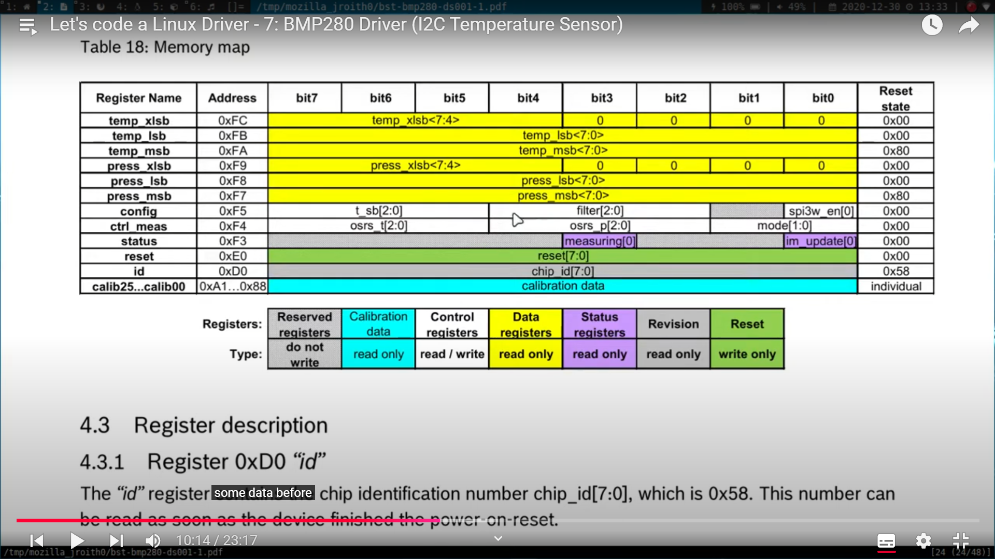
- As can see the id of the sensor can be found at “0xD0”, pressure and temp data in their respective regs.
- Datasheet also presents how to calculate the tetmp and pressure data from the sensor.
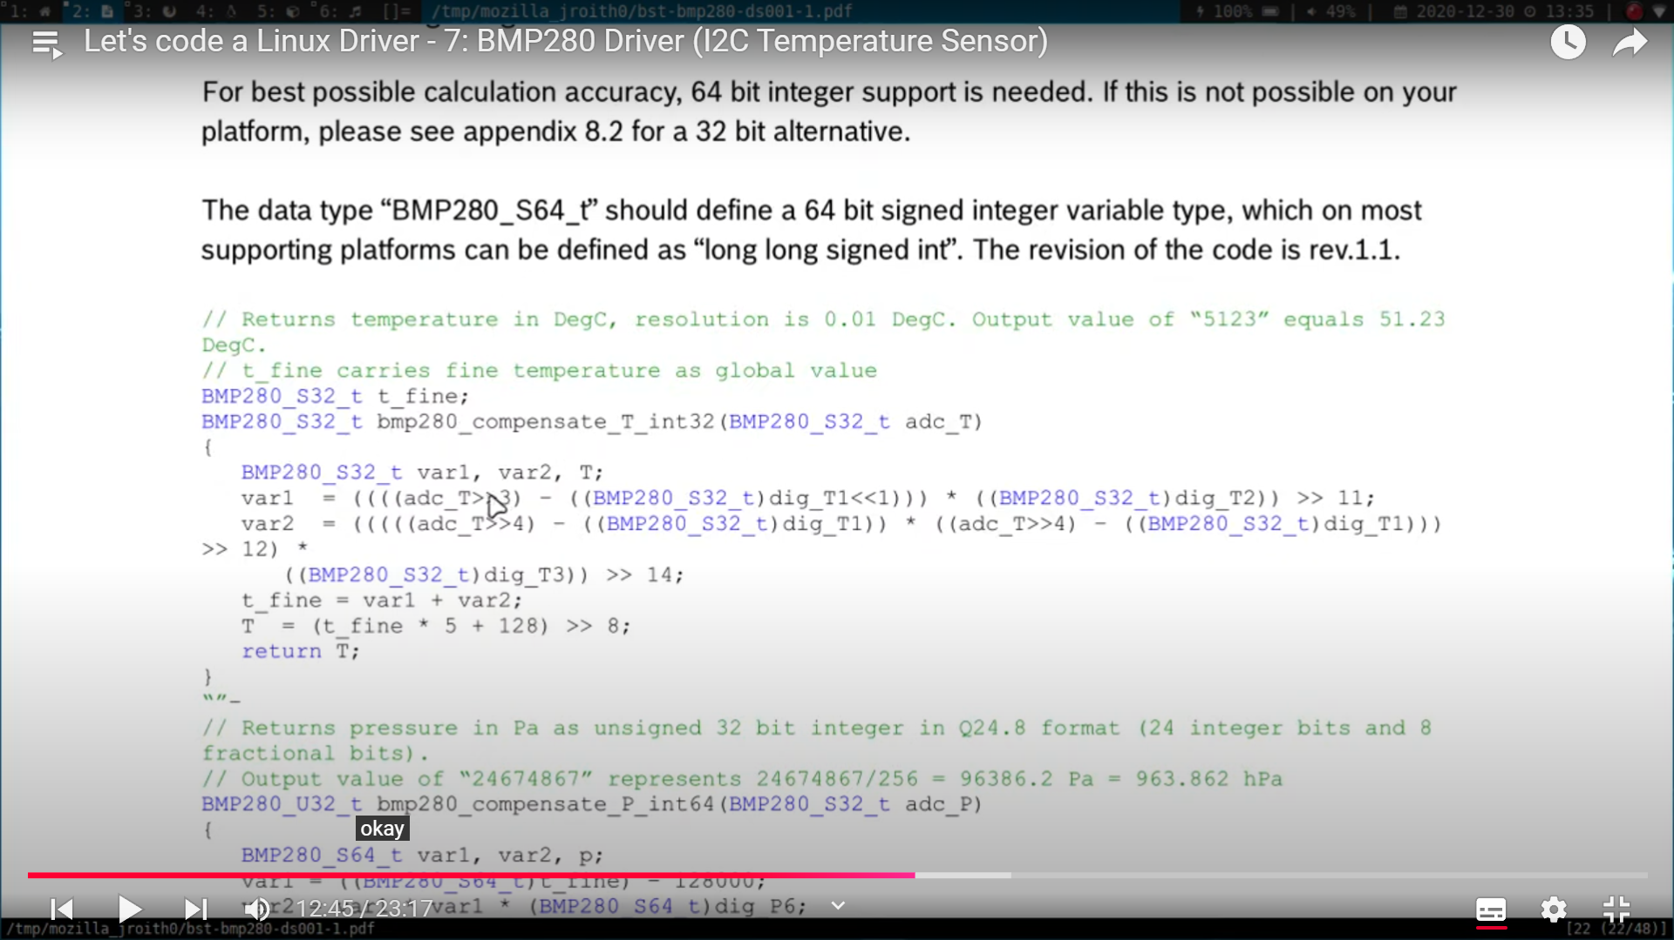

#include <linux/module.h>
#include <linux/init.h>
#include <linux/fs.h>
#include <linux/version.h>
#include <linux/cdev.h>
#include <linux/uaccess.h>
#include <linux/slab.h>
#include <linux/i2c.h>
#include <linux/kernel.h>

#define DRIVER_NAME "bmp280"
#define DRIVER_CLASS "bmp280Class"

static struct i2c_adapter * bmp_i2c_adapter = NULL;
static struct i2c_client * bmp280_i2c_client = NULL;

/* Meta Information */
MODULE_AUTHOR("Johannes 4Linux");
MODULE_LICENSE("GPL");
MODULE_DESCRIPTION("A driver for reading out a BMP280 temperature sensor");
MODULE_SUPPORTED_DEVICE("NONE");

/* Defines for device identification */
#define I2C_BUS_AVAILABLE 1 /* The I2C Bus available on the raspberry */
#define SLAVE_DEVICE_NAME "BMP280" /* Device and Driver Name */
#define BMP280_SLAVE_ADDRESS 0x76 /* BMP280 I2C address */

static const struct i2c_device_id bmp_id[] = {
{ SLAVE_DEVICE_NAME, 0 },
{ }
};

static struct i2c_driver bmp_driver = {
.driver = {
.name = SLAVE_DEVICE_NAME,
.owner = THIS_MODULE
}
};

static struct i2c_board_info bmp_i2c_board_info = {
I2C_BOARD_INFO(SLAVE_DEVICE_NAME, BMP280_SLAVE_ADDRESS)
};

/* Variables for Device and Deviceclass*/
static dev_t myDeviceNr;
static struct class *myClass;
static struct cdev myDevice;

/* Variables for temperature calculation */
s32 dig_T1, dig_T2, dig_T3;

/**
* @brief Read current temperature from BMP280 sensor
*
* @return temperature in degree
*/
s32 read_temperature(void) {
int var1, var2;
s32 raw_temp;
s32 d1, d2, d3;

/* Read Temperature */
d1 = i2c_smbus_read_byte_data(bmp280_i2c_client, 0xFA);
d2 = i2c_smbus_read_byte_data(bmp280_i2c_client, 0xFB);
d3 = i2c_smbus_read_byte_data(bmp280_i2c_client, 0xFC);
raw_temp = ((d1<<16) | (d2<<8) | d3) >> 4;

/* Calculate temperature in degree */
var1 = ((((raw_temp >> 3) - (dig_T1 << 1))) * (dig_T2)) >> 11;

var2 = (((((raw_temp >> 4) - (dig_T1)) * ((raw_temp >> 4) - (dig_T1))) >> 12) * (dig_T3)) >> 14;
return ((var1 + var2) *5 +128) >> 8;
}

/**
* @brief Get data out of buffer
*/
static ssize_t driver_read(struct file *File, char *user_buffer, size_t count, loff_t *offs) {
int to_copy, not_copied, delta;
char out_string[20];
int temperature;

/* Get amount of bytes to copy */
to_copy = min(sizeof(out_string), count);

/* Get temperature */
temperature = read_temperature();
snprintf(out_string, sizeof(out_string), "%d.%d\n", temperature/100, temperature%100);

/* Copy Data to user */
not_copied = copy_to_user(user_buffer, out_string, to_copy);

/* Calculate delta */
delta = to_copy - not_copied;

return delta;
}

/**
* @brief This function is called, when the device file is opened
*/
static int driver_open(struct inode *deviceFile, struct file *instance) {
printk("MyDeviceDriver - Open was called\n");
return 0;
}

/**
* @brief This function is called, when the device file is close
*/
static int driver_close(struct inode *deviceFile, struct file *instance) {
printk("MyDeviceDriver - Close was called\n");
return 0;
}

/* Map the file operations */
static struct file_operations fops = {
.owner = THIS_MODULE,
.open = driver_open,
.release = driver_close,
.read = driver_read,
};

/**
* @brief function, which is called after loading module to kernel, do initialization there
*/
static int __init ModuleInit(void) {
int ret = -1;
u8 id;
printk("MyDeviceDriver - Hello Kernel\n");

/* Allocate Device Nr */
if ( alloc_chrdev_region(&myDeviceNr, 0, 1, DRIVER_NAME) < 0) {
printk("Device Nr. could not be allocated!\n");
}
printk("MyDeviceDriver - Device Nr %d was registered\n", myDeviceNr);

/* Create Device Class */
if ((myClass = class_create(THIS_MODULE, DRIVER_CLASS)) == NULL) {
printk("Device Class can not be created!\n");
goto ClassError;
}

/* Create Device file */
if (device_create(myClass, NULL, myDeviceNr, NULL, DRIVER_NAME) == NULL) {
printk("Can not create device file!\n");
goto FileError;
}

/* Initialize Device file */
cdev_init(&myDevice, &fops);

/* register device to kernel */
if (cdev_add(&myDevice, myDeviceNr, 1) == -1) {
printk("Registering of device to kernel failed!\n");
goto KernelError;
}

bmp_i2c_adapter = i2c_get_adapter(I2C_BUS_AVAILABLE);

if(bmp_i2c_adapter != NULL) {
bmp280_i2c_client = i2c_acpi_new_device(bmp_i2c_adapter, &bmp_i2c_board_info);
if(bmp280_i2c_client != NULL) {
if(i2c_add_driver(&bmp_driver) != -1) {
ret = 0;
}
else
printk("Can't add driver...\n");
}
i2c_put_adapter(bmp_i2c_adapter);
}
printk("BMP280 Driver added!\n");

/* Read Chip ID */
id = i2c_smbus_read_byte_data(bmp280_i2c_client, 0xD0);
printk("ID: 0x%x\n", id);

/* Read Calibration Values */
dig_T1 = i2c_smbus_read_word_data(bmp280_i2c_client, 0x88);
dig_T2 = i2c_smbus_read_word_data(bmp280_i2c_client, 0x8a);
dig_T3 = i2c_smbus_read_word_data(bmp280_i2c_client, 0x8c);

if(dig_T2 > 32767)
dig_T2 -= 65536;

if(dig_T3 > 32767)
dig_T3 -= 65536;

/* Initialice the sensor */
i2c_smbus_write_byte_data(bmp280_i2c_client, 0xf5, 5<<5);
i2c_smbus_write_byte_data(bmp280_i2c_client, 0xf4, ((5<<5) | (5<<2) | (3<<0)));
return ret;

KernelError:
device_destroy(myClass, myDeviceNr);
FileError:
class_destroy(myClass);
ClassError:
unregister_chrdev(myDeviceNr, DRIVER_NAME);
return (-1);
}

/**
* @brief function, which is called when removing module from kernel
* free alocated resources
*/
static void __exit ModuleExit(void) {
printk("MyDeviceDriver - Goodbye, Kernel!\n");
i2c_unregister_device(bmp280_i2c_client);
i2c_del_driver(&bmp_driver);
cdev_del(&myDevice);
device_destroy(myClass, myDeviceNr);
class_destroy(myClass);
unregister_chrdev_region(myDeviceNr, 1);
}

module_init(ModuleInit);
module_exit(ModuleExit);

SPI driver (BMP 280 temp sensor)
- As there are 2 SPI drivers running and we were writing the spi driver which was running we needed to disable the Spi first, so using changin dts file SPI0 was disabled
- DTS file:
/dts-v1/;
/plugin/;

/ {
compatible = "brcm,bcm2708";

fragment@0 {
target = <&spidev0>;

__overlay__ {
status = "disabled";
};
};
};

- Driver code:
#include <linux/module.h>
#include <linux/init.h>
#include <linux/spi/spi.h>

/* Meta Information */
MODULE_LICENSE("GPL");
MODULE_AUTHOR("Johannes 4 GNU/Linux");
MODULE_DESCRIPTION("A simple LKM to read and write some registers of a BMP280 sensor");

#define MY_BUS_NUM 0
static struct spi_device *bmp280_dev;

/**
* @brief This function is called, when the module is loaded into the kernel
*/
static int __init ModuleInit(void) {
struct spi_master *master;
u8 id;
u8 val[] = {0x75, 0x40};

/* Parameters for SPI device */
struct spi_board_info spi_device_info = {
.modalias = "bmp280",
.max_speed_hz = 1000000,
.bus_num = MY_BUS_NUM,
.chip_select = 0,
.mode = 3,
};

/* Get access to spi bus */
master = spi_busnum_to_master(MY_BUS_NUM);
/* Check if we could get the master */
if(!master) {
printk("There is no spi bus with Nr. %d\n", MY_BUS_NUM);
return -1;
}

/* Create new SPI device */
bmp280_dev = spi_new_device(master, &spi_device_info);
if(!bmp280_dev) {
printk("Could not create device!\n");
return -1;
}

bmp280_dev -> bits_per_word = 8;

/* Setup the bus for device's parameters */
if(spi_setup(bmp280_dev) != 0){
printk("Could not change bus setup!\n");
spi_unregister_device(bmp280_dev);
return -1;
}

/* Read Chip ID */
id = spi_w8r8(bmp280_dev, 0xD0);
printk("Chip ID: 0x%x\n", id);

/* Write to config reg */
spi_write(bmp280_dev, val, sizeof(8));
id = spi_w8r8(bmp280_dev, 0xF5);
printk("Config Reg. value: 0x%x\n", id);

printk("Hello, Kernel!\n");

return 0;
}

/**
* @brief This function is called, when the module is removed from the kernel
*/
static void __exit ModuleExit(void) {
if(bmp280_dev)
spi_unregister_device(bmp280_dev);

printk("Goodbye, Kernel\n");
}

module_init(ModuleInit);
module_exit(ModuleExit);

UART:
- Here again we need to disable the UART using dts file
- DTS code:
/dts-v1/;
/plugin/;
/ {
compatible = "brcm,bcm2835";
fragment@0 {
target = <&uart1>;
__overlay__ {
echodev {
compatible = "brightlight,echodev";
status = "okay";
};
};
};
};
- Driver code:
#include <linux/module.h>
#include <linux/init.h>
#include <linux/serdev.h>
#include <linux/mod_devicetable.h>
#include <linux/property.h>
#include <linux/platform_device.h>
#include <linux/of_device.h>

/* Meta Information */
MODULE_LICENSE("GPL");
MODULE_AUTHOR("Johannes 4 GNU/Linux");
MODULE_DESCRIPTION("A simple loopback driver for an UART port");

/* Declate the probe and remove functions */
static int serdev_echo_probe(struct serdev_device *serdev);
static void serdev_echo_remove(struct serdev_device *serdev);

static struct of_device_id serdev_echo_ids[] = {
{
.compatible = "brightlight,echodev",
}, { /* sentinel */ }
};
MODULE_DEVICE_TABLE(of, serdev_echo_ids);

static struct serdev_device_driver serdev_echo_driver = {
.probe = serdev_echo_probe,
.remove = serdev_echo_remove,
.driver = {
.name = "serdev-echo",
.of_match_table = serdev_echo_ids,
},
};

/**
* @brief Callback is called whenever a character is received
*/
static int serdev_echo_recv(struct serdev_device *serdev, const unsigned char *buffer, size_t size) {
printk("serdev_echo - Received %ld bytes with \"%s\"\n", size, buffer);
return serdev_device_write_buf(serdev, buffer, size);
}

static const struct serdev_device_ops serdev_echo_ops = {
.receive_buf = serdev_echo_recv,
};

/**
* @brief This function is called on loading the driver
*/
static int serdev_echo_probe(struct serdev_device *serdev) {
int status;
printk("serdev_echo - Now I am in the probe function!\n");

serdev_device_set_client_ops(serdev, &serdev_echo_ops);
status = serdev_device_open(serdev);
if(status) {
printk("serdev_echo - Error opening serial port!\n");
return -status;
}

serdev_device_set_baudrate(serdev, 9600);
serdev_device_set_flow_control(serdev, false);
serdev_device_set_parity(serdev, SERDEV_PARITY_NONE);

status = serdev_device_write_buf(serdev, "Type something: ", sizeof("Type something: "));
printk("serdev_echo - Wrote %d bytes.\n", status);

return 0;
}

/**
* @brief This function is called on unloading the driver
*/
static void serdev_echo_remove(struct serdev_device *serdev) {
printk("serdev_echo - Now I am in the remove function\n");
serdev_device_close(serdev);
}

/**
* @brief This function is called, when the module is loaded into the kernel
*/
static int __init my_init(void) {
printk("serdev_echo - Loading the driver...\n");
if(serdev_device_driver_register(&serdev_echo_driver)) {
printk("serdev_echo - Error! Could not load driver\n");
return -1;
}
return 0;
}

/**
* @brief This function is called, when the module is removed from the kernel
*/
static void __exit my_exit(void) {
printk("serdev_echo - Unload driver");
serdev_device_driver_unregister(&serdev_echo_driver);
}

module_init(my_init);
module_exit(my_exit);

Kthreads:
#include <linux/module.h>
#include <linux/init.h>
#include <linux/kthread.h>
#include <linux/sched.h>
#include <linux/delay.h>

/* Global variables for the threads */
static struct task_struct *kthread_1;
static struct task_struct *kthread_2;
static int t1 = 1, t2 = 2;

/**
* @brief Function which will be executed by the threads
*
* @param thread_nr Pointer to number of the thread
*/
int thread_function(void * thread_nr) {
unsigned int i = 0;
int t_nr = *(int *) thread_nr;

/* Working loop */
while(!kthread_should_stop()){
printk("kthread - Thread %d is executed! Counter val: %d\n", t_nr, i++);
msleep(t_nr * 1000);
}

printk("kthread - Thread %d finished execution!\n", t_nr);
return 0;
}

/* Meta Information */
MODULE_LICENSE("GPL");
MODULE_AUTHOR("Johannes 4 GNU/Linux");
MODULE_DESCRIPTION("A simple example for threads in a LKM");

/**
* @brief This function is called, when the module is loaded into the kernel
*/
static int __init ModuleInit(void) {
printk("kthread - Init threads\n");

kthread_1 = kthread_create(thread_function, &t1, "kthread_1");
if(kthread_1 != NULL){
/* Let's start the thread */
wake_up_process(kthread_1);
printk("kthread - Thread 1 was created and is running now!\n");
}
else {
printk("kthread - Thread 1 could not be created!\n");
return -1;
}
kthread_2 = kthread_run(thread_function, &t2, "kthread_2");
if(kthread_2 != NULL)
printk("kthread - Thread 2 was created and is running now!\n");
else {
printk("kthread - Thread 2 could not be created!\n");
kthread_stop(kthread_1);
return -1;
}
printk("kthread - Both threads are running now!\n");

return 0;
}

/**
* @brief This function is called, when the module is removed from the kernel
*/
static void __exit ModuleExit(void) {
printk("kthread - Stop both threads\n");
kthread_stop(kthread_1);
kthread_stop(kthread_2);
}

module_init(ModuleInit);
module_exit(ModuleExit);

MUTEX
#include <linux/module.h>
#include <linux/init.h>
#include <linux/kthread.h>
#include <linux/sched.h>
#include <linux/delay.h>
#include <linux/mutex.h>

/* Global variables for the threads */
static struct task_struct *kthread_1;
static struct task_struct *kthread_2;
static int t1 = 1, t2 = 2;
static struct mutex lock;

/**
* @brief Function which will be executed by the threads
*
* @param thread_nr Pointer to number of the thread
*/
int thread_function(void * thread_nr) {
int delay[] = { 0, 1000, 500};
int t_nr = *(int *) thread_nr;

/* Working loop */
printk("mymutex - Thread %d is executed!\n", t_nr);

mutex_lock(&lock);
printk("mymutex - Thread %d is in critical section!\n", t_nr);
msleep(delay[t_nr]);
printk("mymutex - Thread %d is leaving the critical section!\n", t_nr);
mutex_unlock(&lock);

printk("mymutex - Thread %d finished execution!\n", t_nr);
return 0;
}

/* Meta Information */
MODULE_LICENSE("GPL");
MODULE_AUTHOR("Johannes 4 GNU/Linux");
MODULE_DESCRIPTION("A simple example for threads in a LKM");

/**
* @brief This function is called, when the module is loaded into the kernel
*/
static int __init ModuleInit(void) {
printk("mymutex - Init threads\n");

mutex_init(&lock);

kthread_1 = kthread_create(thread_function, &t1, "kthread_1");
if(kthread_1 != NULL){
/* Let's start the thread */
wake_up_process(kthread_1);
printk("mymutex - Thread 1 was created and is running now!\n");
}
else {
printk("mymutex - Thread 1 could not be created!\n");
return -1;
}
kthread_2 = kthread_run(thread_function, &t2, "kthread_2");
if(kthread_2 != NULL)
printk("mymutex - Thread 2 was created and is running now!\n");
else {
printk("mymutex - Thread 2 could not be created!\n");
kthread_stop(kthread_1);
return -1;
}
printk("mymutex - Both threads are running now!\n");

return 0;
}

/**
* @brief This function is called, when the module is removed from the kernel
*/
static void __exit ModuleExit(void) {
printk("mymutex - Stop both threads\n");
}

module_init(ModuleInit);
module_exit(ModuleExit);

RACE CONDITION IN DD:
- Suppose 2 processes A and B both have the same device open for writing and both attempts simultaneously to applen data to the device. So they will over write each other data and data will be lost.
- So this condition is called RACE CONDITION.
- For interrupts :
  - The interrupt handler is the top half. The top half will run immedialtly upon receipt of the interrupt and performs only the work that is time ctical such as acknowledging receipt of the interrupt or resetting the hardware.
  - A bottom half is used to process data, letting the top half to deal with new incoming interrupts. Interrupts are enabled when a bottom half runs. Interrupt can be disabled if necessary, but fenerally this should be avoided as this goes against the basix putpose of having a bottom half processing data while listening to new interrupts. The bottom half runs in the future, at a more convenient time, with all interrupts enabled.
  - There are 4 bottom half mechanisms are available in Linux:
    - Work-queue
    - Threaded IRQs
    - Softirqs
    - Tasklets
      - They are used to queue up work to be done at later time. They can be run in parallel, but the dame tasklet cannot be run on multiple CPUs at the same time. Also each tasklet will run only on the CPU that schedules it, to optimize cache usage.
      - They are atomix, so we cannot use sleepIO and such synchoronization primitives as mutexes, semaphore, etc from them. But can use spinlock.
      - We can create tasklet in two ways:
        - Static
          - And we will declare it in this way
Void tasklet_function(unsigned long data);
DECLARE_TASKLET(tasklet_example, tasklet_function, tasklet_data);
tasklet_schedule(&taskelt_example);
          - Example –
Void tasket_func(unsigned long data){
Printk(KERN_INFO”Executing tasklet: data = %ld\n”, data);
}
Static irqreturn_t irq_handler(int irq, void *dev_id){
Printf(KERN_INFO“interrupt occurred”);
Tasklet_schedule(&tasklet);
Return IRQ_HANDLED;
}
        - Dynamic
          - For dynamic we will just remove DECLAR thing and add this into device inti funcc to dynamically declare and also need to allocate the memory using kmalloc.
Tasklet = kmalloc(sizeof(struct tasklet_sturct), GFP_KERNEL);
Tasklet_init(tasklet, tasklet_fun, 0);
          - Here we use 0 as to enable it and we also need to free the tasklet memory and also kill the tasklet at the exit.
Kfree(tasklet);
Tasklet_kill(tasklet);
      - Tasklet struct:
Struct Tasklet_struct{
Struct tasklet_struct *next;
Unsigned long state;
Atomix_t count;
Void (*func)(unsigned long);
Unsigned long data;
};
- LINIUX kernel provides several mechanisms for avaoiding and managing race conditions;
  - Interrupt control
    - Interrupts are used when we need to write on the driver. When we use interrupts we disable other interrupts so that the code does not get preempted and then after completing it enables the interrupts before leaving the section.
    - To disable the interrupt, kernel clears the IF_flag of the eflag register, when it wxecutes cli() macro and enable the interrupt by sti().
    - An eflag is a redister that stores the interrupt state in the IF flag.
      - Save_flags(unsigned long local_variable);
      - Cli() – to disable the interrupts
      - Restore_flag(unsigned long local_variable);
      - Sti() – to enable the interrupts.
    - The issue with interrupt control is the interrupt latency. Interrupt latency means ttime to clear interrupt from the raise time. High interrupt latency system is not good.
    - This is only good if the critical section is small.
  - Semaphores
    - In general, semaphohre can be expensive to use because they can put the calling process to sleep.
    - To avoid to put the process to sleep, we can use SPINLOCK.
    - But when we use down_interruptible(&sem), if the process was able to take the shared resource, it will use it and if any signal is received when the process is in shared resource it will react to it, but if we use down instead of down_interruptible then, if it fails to accuire shared resource, it will wait to complete the given process but it will not let the process to be interrupted by any signals or preemption. So the system will not get interrupted and the pocess will leave the shared resource and the waiting process will access the section without getting interrupted.
    - Code that uses down_interruptible to obtain a semaphore must not call another function that also attempts to obtain that semaphore, if so DEADLOCK will result.
    - Up(&sem) – this function call will increment the value od the semaphore and wake up any processes that are waiting for the semaphore to become available.
  - Spinlocks
    - Spinlocks are declared with a type of spinlock_t which is defined in <linux/spinlock.h> and <asm/spinlock.h>.
    - First spinlock must be initialized
      - Spin_lock_init (spinlock_t *lock);
    - A process entering a critical section will obtain the lock with spin_lock
      - Spin_lock(spinlock_t *lock);
    - The lock is released at the end with spin_unlock
      - Spin_unlock (spinlock_t *lock);
    - Spin_lock_irqsave( spinlock_t *lock, unsinged long flags);
      - This version also acwuies the lock; in addition, it disables interrupts on thelocal processor and stores the current interrupt state in flags.
    - Spin_lock_bh(spinlock_t *lock);
      - Obtains the given loakc and prevents the execution of bottom halves.
      - Bottom halves are part of interrupt programs which are scheduled to execute later.
    - Spin_unlock_bh(spinlock_t *lock);
  - Reader-writer Spinlock
    - Regular sinlocks works well for the most situations encounter bu DD writers.
    - But if you have a situation in which numerous threads need to access critical data in a read-only mode, the spinlock is not an efficient way.
    - Insuch situations, we need more efficient tool to allow all readres to access the data simuyltaneously.
    - In this case, Linux has a different ype of spinlock, which is a reader-writer spinlock.
    - The func are same as spinlock but instead of spin just write read or write.
      - Eg:- read_lock_init(rwlock_t *lock);
      - Write_lock(rwlock *lock);

The difference between semaphore and spinlock is that if a process is waiting to accuire the shared resources the process will be sleep, but in spinlock the waiting process will be constantly checking if the lock is there or not.

File IO in linux:
- When we read and write on memory we do it in blocks, ans block size is normally 4 k (4096).
- When we need to write or read from the block buffer, the system will check if that block is in the memory(RAM/cache) or not. If not present page will be called from the HD and will be stored in the memory.
- Now temporary locality, if the processor read the block it is likely to read the next line so it will already store the line in memory so improving throughput.
- Synchronized I/O :- when we write some data or change some data in the memory, the data in the hard memory is noth changed only cache memory is changed. So after some time the kernel will update the hard emory. But if sudden power cut happens, there is no time to update the hard memory and might get unchanged. It is critical in RTOS or some other applications, so for this type of processes synchronized IO is used, where the processor make sures that the changes are updated to the physical memory everytime it gets updated.
- In file there are many types of IO eg:- open, read, close, create, lseek, write, unlink, sync, fsync, truncate and ftruncate.
- Unlink – deletes pathname form fs if this was the last link and no process is having this file open, the file is deleted and return 0 on success.
- Buffer flushing – this refreshes and clears the kernel buffer
  - Sync – this before clear, it makes sure that data is written to the respective file before clearing the buffer. It does not return anything and it is always successfully.
  - Syncfs – this will only write the device files which was mentioned in during the call.
  - Fsync – flashes all the modified buffers for the file referred and updates the given device memory.
  - Fdatasync – all the data is sync with the hardware, however some optimization in terms of minimizing data output is done. Only metadata which is essential to read the file later on is synchronized.
- Truncate – truncates the regular files to the specified length. Used when path is provided.
- Ftrancate – does the same as truncate, if we want to short the file it will only store the file length data and the rest data will be lost. The file offset is not changed even after trnacating the file. Here fd is used instead of file.

**************** KERNEL AND IT RELATED THINGS
- KDUMP (Kerenl Crash Dump)
- A kernel crash dump refers to a peortion of the contents of volatile mem (RAM) that is copied to disk whenever the execution of the kernel is disrupted.
- Due to issues the system crashes and will generate ops. This log are maintained in log and we want to capture this log which can help to debug the system.
- The following events can xause a kernel disruption:
  - Kernel Panic
  - Non maskable interrupts (NMI)
  - Machine check exception (MCE)
  - Hardware failure
  - Manual intervention
- The KDUMP will copy all the content from the RAM and push the log and data of the crash in the file somewhere in the system storage device.
- KDUMP is an utility used to capture the system core dum in the event of system crashes. These captured core sumps can be used later to analyze the exact cause od the system failure and implement the necessaty fix to prevent the crashes in future.
- KDUMP
- Reserves a small portion of the memory for the secondary kernel called “crashkernel”.
- This secondary or crash kernel is used the capture the core dump image whenever the system crashes.

- Steps to save the core logs:
- First install the kdump.
- Set crashkernel in grub.conf
  - Once the package is installed, edit /boot/grub/grub.conf file and set the amount of memory to be reserver for the kdump crash kernel.
  - Or open /etc/default/grub and we will add this or similar line to tell the grub that we have allocated some memory to the core dump at this location.
    - “GRUB_CMDLINE_LINUX=”crashkernel=512M specter_v2=retpoline rd.lvm.lv=centos/root rd.lvm.lv=centos/swap rhgb””.
    - Cross check that this line is add to the grub using:- “cat /proc/cmdline”.
    - Minimum you should assign “128M” size for a machine with 2G memory or higher.
    - You can also set the memory size to automatically using “auto” (instead of 512M).
  - Once the kernel crashes, the core fump can be captured to local fs or remote fs based on the setting defined in /etc/kdump.conf.
    - Eg if you want to store in /dev/vg/lv_kdump file just give “raw /dev/vg/lv_kdump”. Here we selected that the fs is a raw type.
    - To save that in ext4 fs we set that as “ext4 /dev/vg/lv_kdump”.
    - To save to a nfs server just give “nfs my.service.com:/export/tmp”.
    - Or to store in another system just give this two 1 – “ssh user@my.server.com” 2- “sshkey /root/.ssh/kdump_id_rsa”.
    - And to store it in a locat path or fs we will just use “path /var/crash”.
  - To config the core collector in kdump config file. It is imp to compress the data captured and filter all the unnecessary info from the capture core file. Just uncomment the core collector section in config file “core_collector makedumpfile -c –message-level 1 -d 31”.
    - -c is to compresses dump data by each page
    - -d is the number of specified pages (31th type of pages) that are unnecessary and can be ignored.
  - Makedumpfile specified in the core_collector actually makes a small dumpfile by compressing the data. It provides 2 dumpfile formats 1) ELF format and 2) kdummp-compressed format (defualt).
    - The kdump-compressed format can be read only with the crash utility and it can be smaller than ELF format, but ELF format is readable with both GDB and crah utility.
  - If you uncomment the line #default sheel then the shell is invoked if the kdump fails to collect the core. Then the admistrator can manually take the core dump using makedumpfile cmds. Once kdump is config, restart the kdump services using “systemctl enable kdump.service” or to start the service in the current session, use “systemctl start kdump.service”.
  - To make sure the kdump service is active use “systemctl is-active kdump”.
  - To manually trigger the core dump use “echo 1> /proc/sys/kernel/sysrq” (to enable the sysrq) or “echo c > /proc/sysrq-trigger” (to crash the kernel).
    - Here instead of 1 we can give different positive number.
    - Sysrq (system request key)– This is a cmd that the system will surely respond no matter what if it is active.

- Solving/debugging the dump.
- If you created the kernel crash and were able to reboot the system succeffully, a core file is generated under /var/crash. To view it use “ls -IR /var/crash”.
- To analyze the crash use crash utility or KGDB and you need to ensure the “kernel-debuginfo” package is present and it is at the same level as kernel.
- Launch the crash tool as shown below and after this cmd, you will get a crash prompt, where you can execute crash cmds: “crash /var/crash/file_name/vmcore usr/lib/debug/lib/module/’uname -r’/vmlinux”.
- Crash>
- In this you will be able to see all the info of the kernel, the rpcesses it was working on , which CPU was utilized for what program, what was the process id, etc.
- You can see, analyze at register level also to understand what it was working on and due to which process it got crashed and everything.
- Always add this line “kernel.panic = 3” or “kernel.panic<0”, this means that it will wait for 3 sec after the kernel crashes and it will automatically reboots after 3 secs. If set less than 0 then as soon as crash happens the kernel will immediately reboots.
- Never set kernel.panic=0, this means that after kernel crashes it will wait forever and will not reboot automatically. If you are doing something which need kernel.panic=0 its okay.

- KDUMP view process
- View the process when system crashed, execute ps cmd at the crash prompt, which will display all the running process when the system crashed.
  - Crash> ps
- To view swap space when system crashed execute swap cmd.
  - Crash>swap
- To view IPCs when system crashed, use this cmd.
  - Crash>ipcs
- To view IRQ
  - Crash>irq -s
- Other important. Crash> is ahead of all this:
  - Vtop – translates a user or kernel virtua; address to its physical add.
  - Foreach – displays data for multiple tasks in the system.
  - Waitq – displays all the tasks queued on a wait queue.
  - Vm – will display the virtual memory usage when the system crashed.
  - Files – displays the open files when the system crashed.
  - Sys – displays system info when the system crashed.
  - Help – to show the cmds and what they do.
  - Bt – backtrace the processes, stack, etc.

- KGDB
- To run the KGDB, we need to connect the target machine with the host machine and so we will required 2 machines.
- We will connect the host machine with the target machine through serial connection (although we can connect with other ways like gbd client-server internet), for this we need to mention the serial port on which other machine is connected and remotely we will control the kernel.
- To do this we can use qemu where we can start the kernel boot without rebooting the system. Like this is a simulation application where it will give a separate terminal where we can restart the kernel with the updates and if any error is encounter we can kill it with other terminal as this is a simulation application. So we will attach KGDB while starting the qemu and we can do kernel debugging.
- To run KGDB we need to enable the KGDB and related things in the config files.
- We will add this cmd “kgdbwait kgdbboc=ttyS0,115200”, in the terminal cmd while running the qemu. Because of this cmd the system will wait till serial connection is establish.
- Here the system will send a signal to the host machine that I am restarting and the host machine will send to target machine that connection is succefull now start rebooting.
- We can also remote dubug using remote client system using client-server gdb. In this case the interface will be ethernet. Here I need to mention the target remote server and it will be a TCP connection.
- Using KGDB we can set breakpoints in the system booting. This way we can set breakpoints on the sscheduler to see which tasks will it run, and all other things related to system.

- KDB (Kernel Debugger)
- When we launch using KDB it will launch on that system instead of remote system.

- Pstore
- In dtb we need to reserve some memory for the OOPS and that we will use for pstore.
- If we do not reseve the memory in dtb, we cannot use it for GDB or KGDB.
- We need to save memory for RAMOOPS. All the msgs that will come in RAMOOPS will be stored in Pstore.
- Pstore is nothing but a persistent memory, whenever we do reboot this memory will not go, but as we turn off and on this memory will be gone and new one will be generated.
- We can access this memory in /sys/fs/pstore.

- RAMOOPS
- It is oops/panic logger that writes its logs to RAM before the system crashes. It works by logging oopses wna panica in a circulat buffer. It needs a system with persistent RAM so that the content of that area can susrvive after a restart.

- Steps to solve the kernel problems
- See the details of kernel Pnaic error (id the reason behind it eg:- New kernel, cprrupted initramfs)
- Login the system with toot credentials through rescue mode.
- Take neccessara acions as the reason of getting this error.
  - If new kernel, downgrade it.
  - If corrupted or missing initramfs, regenerate it.

- Gcov:
- Gcov is a source code coverage analysis and statement by statement profiling tool. It generates exact counts of the number of times each statement in a program is executed and annotes sources code to add instrumentation. It comes as a standard utility with GNU CC Suite (GCC).
- Gcov provides the following details:
  - How often each line of code executes?
  - What lines of code are actually executed?
  - How much computing time each section of code uses?
- Compilation cmd “gcc –coverage lib.c test.c -0 test”
- This will generate the following files:
  - Lib.gcno – lib flow graph
  - Test.gcno – test code flow graph
  - Test – test code executable
- Now execute the test code obj files. This will generate the following files:
  - Lib.gcda – lib profile output
  - Test.gcda – test code profile output.
- Now to generate the coverage report, run the following cmd :
  - “gcov –abcfu lib.c”

- Symbol
- A symbol is a name given to a space in the memory which stores data (variables, for reading and writing) instructions (functions for executing).
- It is in programming lang is either a variable or function.

          - Symbol table
- Data struct created by compiler containing all the symbols used in the program.
- Every kernel image that you build has a symbol wtable with it.
- Linux kernel sybol table contains names and addresses of all the kernel symbols.
- When you install the kernel it will be present in /boot/System.map-<linux_version>

          - Export Symbol
- When you define a new func in your module, the default behavious of this func is local, only the module which the func is defined can access it, cannot be accesse by other modules.
- To export this module we need to use EXPORT_SYMBOL (can be used by any kernel module) or EXPORT_SYMBOL_GPL (only used by GPL licensed code).
- Once you export them, they will be available to other modules to use.

          - System.map:- contains symbols of only builtin modules.
          - /proc/kallsyms:- contains sysmbols of dynamically loaded modules as well as builtin modules.

          - Module stacking
- New modules using the symbols expoerrted by the old modules.
- Msdos fs relies on symbols exported by fat module.
- Parallel port printer driver relies on symbols exported by generic parallel port driver (parport).

          - Vesrion magic
- It is a magic string present in the linux kernel and added into the .modinfo section of the linux kernel modules.
- It is used to verify whether the kernel module was compiled for the particular kernel version or not.

          - Tainted kernel
- When kernel is tainted it means that it is in a state that is not supported byu the community.
- In addition some debugging functionality and API calls may be diaabled when the kernel is tainted.
- This happens because of many reasons like, using non-GPL-compatible kernel mdule, use of staging drivers, which are part of the kernel source code but are not fully tested, use of out-of-tree modules, etc.

***************** Linux Network Stack
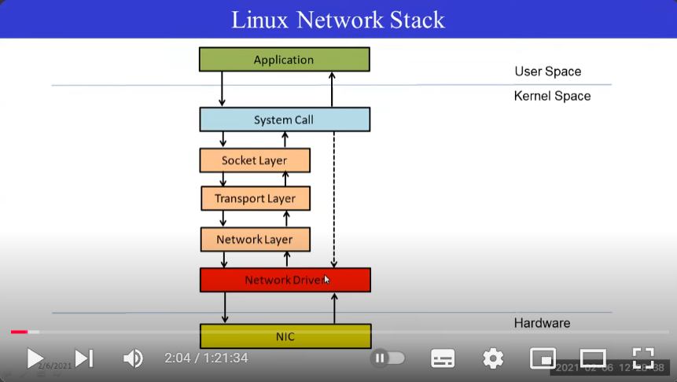

Q) What are IP table?
- Iptables is a Linux firewall program that allows system administrators to control incoming and outgoing network traffic:
- How it works
Iptables uses a command-line interface to match network traffic against a set of rules. These rules are organized into chains, which are groups of rules that define how to treat network traffic packets.
- What it does
Iptables can be used to block specific IP addresses or ports, or to allow certain packets to pass through. For example, you can use iptables to block Christmas tree packets, which have all headers set.
- How to use it
Iptables is installed as /usr/sbin/iptables on most Linux systems. You need to be logged in as the user root to run iptables.
- Related programs
There are other programs that work similarly to iptables, including ip6tables for IPv6, arptables for ARP, and ebtables for Ethernet frames.
Routing table for the data and devic:
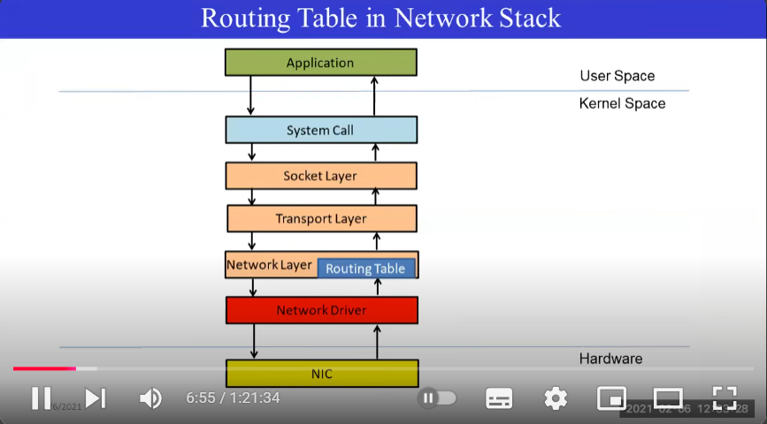

Basic functionality of the network driver:
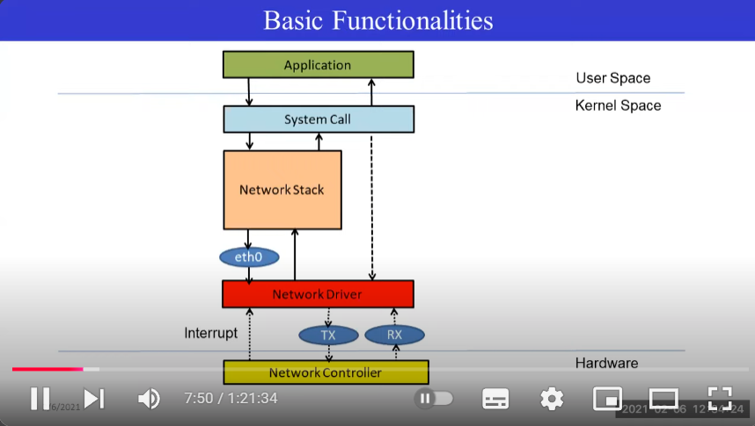

***********Kerel Coding and boot process
- Kernel Memory management functions in C
  - kmalloc — allocate memory
  - kmalloc_array — allocate memory for an array.
  - kcalloc — allocate memory for an array. The memory is set to zero.
  - kzalloc — allocate memory. The memory is set to zero.
  - kzalloc_node — allocate zeroed memory from a particular memory node.
  - kmem_cache_alloc — Allocate an object
  - kmem_cache_alloc_node — Allocate an object on the specified node
  - kmem_cache_free — Deallocate an object
  - kfree — free previously allocated memory
  - ksize — get the actual amount of memory allocated for a given object
  - kstrdup — allocate space for and copy an existing string
  - kstrndup — allocate space for and copy an existing string
  - kmemdup — duplicate region of memory
  - memdup_user — duplicate memory region from user space
  - __krealloc — like krealloc but don't free p.
  - krealloc — reallocate memory. The contents will remain unchanged.
  - kzfree — like kfree but zero memory
  - get_user_pages_fast — pin user pages in memory

- Steps to a booted system:-
  - Bios is executed from ROM.
  - The bios loads the bootloader into address 0x7C00.
  - The bootloader loads the kernel.
- The bootloader is a small prog responsible for loading the kernel of an OS and they are generally small. And put the system into 32 bit protected mode and then executes.
- The CPU rexecutes instruction directly from the bios rom. Then bios loads its self into ram then continues from ram. It also initialize essential hardware.
- The bios looks for a bootloader to boot buy searing all storage mediums for the boot signature “0x55AA”. When it finds this signature it loads the section of this memory to 0x7c00. And process jumps to this address and begin executing OS bootloader.

          - REAL MODE:-
- Real mode is a compatibility mode that all modern interl precessors start in when they are switch on.
- In this mode we can only access 1 MB of RAM, it dies not matter if you have GBs of Ram.
- In this mode you have no security, so in todays tech, when we run a code if invalid mem is accessed it showed error and saves the system, but in real mode there is no safety and my curroput the system.
- So, now a days still all x86 CPUs still start in real mode when powered up, the transition to protected mode happens very quickly during boot process, making it negligible. This is still there because to support backwards compatibility so that it can support older software designed for booting.
- X86S will not use real mode. All systems having UEFI (Unified Extensible Firmware Interface) does not have real mode.

          - Protected mode:-
- Here it is a 4GB addressable memory of instead of 1MB ram of real mode.
- We gain access to 32 bit inst and can easily work with 32 bit regs.

          - The logo during booting process:-
- During booting, we can can see a logo of Lenovo or the the companies logo, we can do that; we just need to start writing to the mem address, it starts taking input during the boot process.
- In most CPUs the mem address “0xB8000” is the starting place to write the during the booting stage.
- So, calculate the screen size (height and width) and set that as macro or variable in the code.
- Now, suppose the system is 8 bit arch, then the first will take the input you want to place and the next input to displaying which colour you want.
- Eg:-
Void print_screen(){
Char* video_mem = (char*)(0xB8000);
Video_mem[0]= ‘A’;
video_mem[1]= 1;
}
- So the A will be displayed with the colour respective to 1. Here we need to see if the input is little edian or big.
- And also to move to next line, the system does not know that ‘\n’ means new line, so we need to place it in if sentence and then tell the system to go to new line.

*****************IOT AND PROTOCOLS
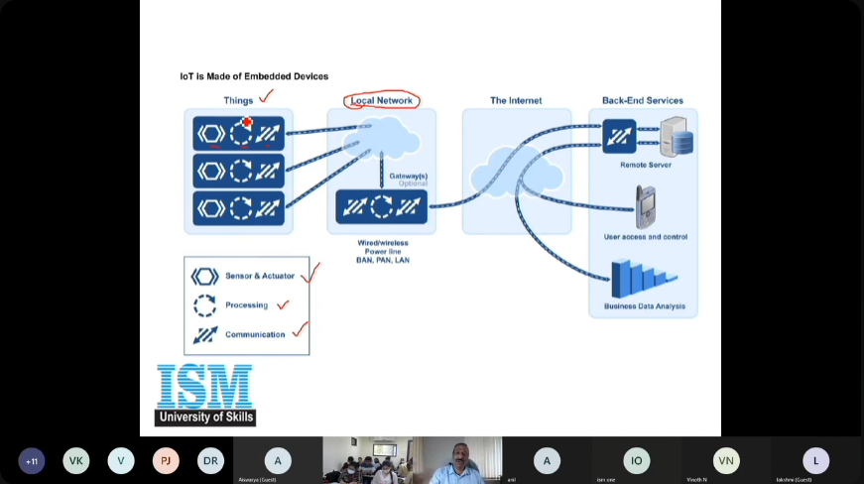
This is how IoT works on back side.
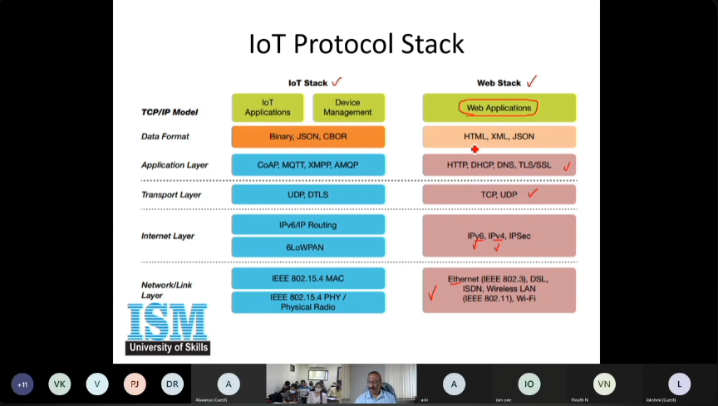

NFC (near field communications):
- NFC is used to have contactless data transfer. It can communicate at lower distance of around 4 cm.
- It is working at 13.56MHz of ISM band. This is an unlincesend band and can be used by any device. It has data rate of 106 kbps to 848kbps (as data rate increases, the distance decreases).
- In other protocols like wifi, zigbee and any other distant transmission protocols works on 2.4 GHz or more and so they uses powerful antennas.

- Working:-
- It is based on inductive coupling between 2 antennas.
- RFID helps to track inventory before the sale, while NFC is aimed at becoming part of a product utility after the sale.
- NFC tags cant act as readers and they are passive devices i.e they do not need power source to act.
- NFC reader initiates RF communication by cmds and NFC tag responds to cmds by tag info.
- NFC reader can also act as NFC tag, and 2 NFC reader can transfer data in full duplex mode.

- Advantages:
- Secure comms, no special software is required, no manual confi needed, no search and pairing required.

- Disadvantages:
- Short distance communications, low data rate.

******************* FILE SYSTEM IN LINUX
- Provided space for non volatile storage of data.
- A specific type of data storage format are Data and Meta-data.
- Every fs types use its own metadata struct to define how the data is stored and accessed.
- Some mostly used fs are EXT4, EXT3, FAT-32, NTFS.

- Disadvantage of ptintk as debugging tools:
- Modifying source code may not be trival and quick.
- Unnecessary delay the overall performance.
- Best way to get the info is to query the system.

- Why proc?
- One of the techniques to get info from kernel and kernel modules are through query.
- The /proc fs is a special, software created fs which provides an interface to communicate between user space and kernel space.
- It is a virtual fs nothing to do with actual fs. The main purpose of this is to communicate between user space and kernel space for system info. Data is not stored in non-virtual memory. It does not have actual file so proc has no data storage format like stand fs.
- /proc is not available in all OS.
- It contains the useful info about the processes that are currently running.
  - /proc/modules – provides the list of modules.
  - /proc/meminfo – stats memory usage statistics.

- Why the create call in the init module should be placed at the end of the init module and at the start of the cleanup module in device drivers?
- We can place the create call at the start or anywhere inside the init module and end module, but it is better to place it in the end in int and start in the cleanup, because this struct or call will create an interface which a user will be able to use it.
- So if we place the create call at the start of the init and accidently the kernel was not able to provide enough space or device number or any other reason it showed some error, the interface which was created will stay create and the user and to remove that part or interface we need to remove that part while cleanup the code, which is nasty process.
- So if any error occurs while init, the kernlel will trhow error earlier before creating the interface and we so no interface will be created so no issue or removing the interface from the space. Same goes with the cleaup module as it is placed at the beginning of the remove.

- File Systems
- Inode:- indoe hass 2 types 1) ondisk inode 2) input inode. It is rep of files. Everything is file in UNIX, so inode is view of file all about how it created, what data it holds, etc.
- Directory Entries (dirent):- contents of directory, so to go through from place to place in files it uses dir entry.
- Superblock:- root block and it contains log files and everything.
- Extent:- earlier everything was in blocks but now due to increase in size of block we store it in contiguous way of blocks and it is called extent.
- Metadata:- is not data, it is information what the data is about, it holds other data like its inode detail, dir loc, etc related to data.
- Journal:- it is a place to write the logs of the file before we do operation on the file. It is like a transaction log.
- Fsck:- it is bunch of tools to check the details of the files and can be called as file sys checker if it is corrupted or not and so on.
- ACID properties
- Atomicity means all the instructions run or none.
- Concurrency – transactions running in parallel should run as if they are running in serial.
- Isolation – results of one ops not exposed till committed
- Durability – effects are not lost after committed.
- Snapshot – rep of fs used if file got corrupted it can go back version.
- Deduplication – to remove duplication from the system to save memory like storing the contents of a file in this dir and same dir to other location. This can be changed and saved using dedub.
- Compression – compress the data to save mem.
- Clustering – accessing the files from multiple nodes or reverse.

- Storage media
- Hard disk drivers – mechanical, subjected to wear and tear and RAID protects agains data failure
- Flash (NAND) – Non volatile storage and limited by write/erase cycles.
- Connectivity – SATA, SCSI, NVMe.

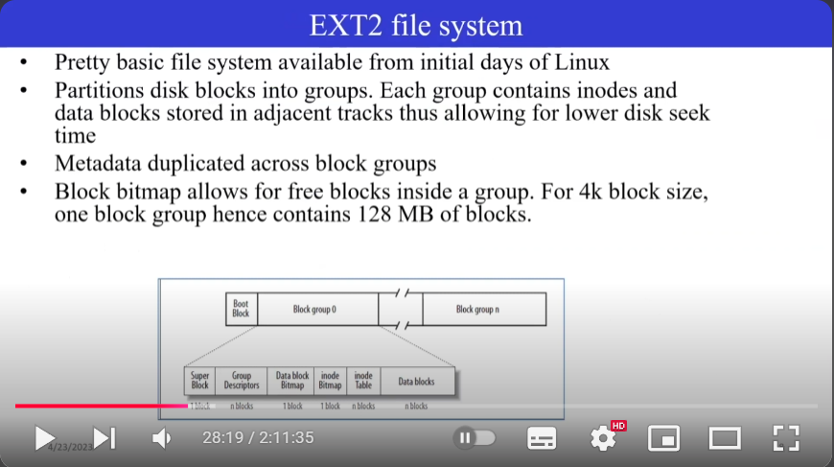

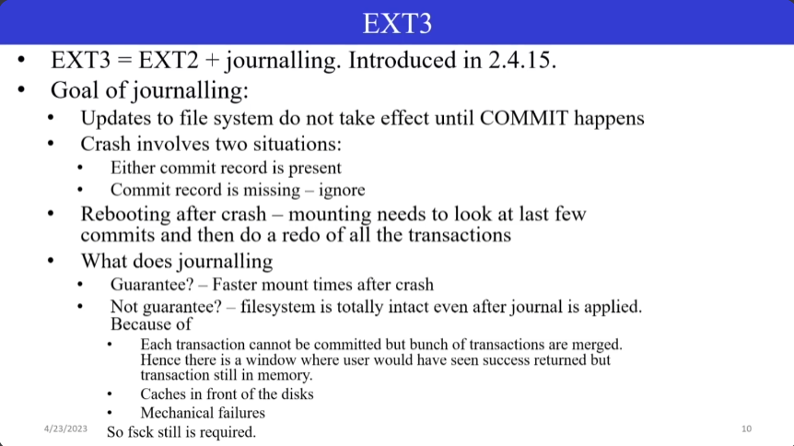

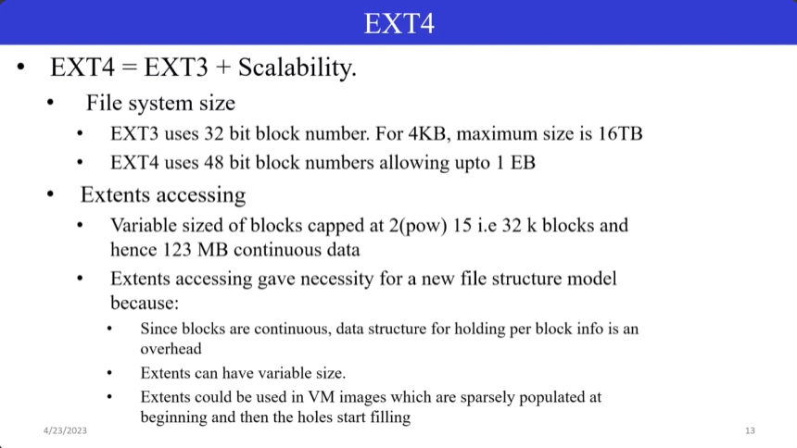

******************* FILE OPERATIONS

- Different types of locks for file
- Flocks:-
  - This is used to lock the section of the file
    - Include <fcntl.h,sys/types.h,unistd.h,sys/file.h,stdio.h>
Int main(){
Int fd, loc_res;
Fd = open(“file_name”, O_RDWR);
Loc_res=flock(fd,LOCK_SH);
Printf(“result of locking = %d \n”, loc_res);
Getchar();
}
Here we have used LOCK_SH (locked shared), so other process can access the lock section.

If we use LOCK_EX (lock exclusive) locking the file and no other file can access this file until this process releases this file. If other process tries to run this file, it will be send to blocking state and when the process releases the file it will start executing. So, this wastes CPU resources and so we can use non_blocking args which will return -1 if the file cannot be open.

Loc_res=flock(fd,F_LOCK,6);
Here if we mention the size of lock, we will just lock this section of the file. This section starts from the pointer loc to the mentioned size. So no other file will be able to success this location of the file, but can access the file for other location.

Loc_res=flock(fd,F_ULOCK,6);
Here this is the way of unlocking the section of the file without closing the file.
We can also provide without any size to unlock the whole file section.

The original struct of flock is
Struct flock fl = {fl.l_type, fl.l_whence, fl.l_start, fl.l_len, fl.l_pid}
Where;
fl.l_type = F_WRLCK, F_RDLCK, F_UNLCK
fl.l_whence = SEEK_SET, SEEK_CUR, SEEK_END
fl.l_start = 0, offset from l_whence
fl.l_len = 0, length, where 0=EOF
fl.l_pid = getpid()

************** Interrupts
Q) how a CPU know and handles the interrupts?
- All the devices are connected to PCIe and PCIe is connected to CPU through INTR line. The CPU is also connected to NMI (Non-maskable Interrupts) to help the interrupts. There are 8 interrupts lines in PCIe from IR0-IR7 and IR0 has the highest priority. Now, sppose an interrupt occurred from IR1 and IR7. So the PCI will send the signal to CPU using INTR line and it will also change the state of IR registers to 0 for the given IR numbers. The CPU will receive the signal and will send an acknowledgement signal “INTRACK” and will ask for vector number. Vector number is a number assigned by the PCIe to all the hardware which is always unique. So after receiving the Ack from the cpu it will send the vector number to cpu and CPU will start the interrupt handling. Now after completing the IR it will now set the IR1 to 1 as “0” mean interrupt requested and “1” means no interrupt on that line. After setting the IR, it will ask if there is anyohter IR pending to PCIe and if ther is any other IR in pending state it will be send to the CPU and the process starts again.

Q) If multiple devices are sharing the lines how will the CPU know which device is the one? EG in interrput line 0 there are 8 devices connected , how will CPU know on which device to work on from the devices connected to the line 0
- When multiple devices share an interrupt line, the CPU determines which device triggered the interrupt by checking additional information provided by the device itself, usually through a dedicated register or by polling each device connected to that shared line within the interrupt handler routine, effectively asking each device if it caused the interrupt.
Step 1) wWhen an interrupt is triggered on line 0, CPU enters the interrup handler routine.
Step 2) If polling is used - The interrupt handler code then checks the status register of each of the 8 devices connected to line 0 to see which one is signaling an interrupt. Polling can add overhead to the system, especially if many devices share an interrupt line.
Step 3) Some systems might use priority-based interrupt handling where the interrupt controller prioritizes interrupts from different devices on the same line.

**************PCIe (Peripherical component Interface express)
PCI (Peripherical component Interface): it is an interface which helps to connect the hardware like network card, memory, etc to the system.
Q) What is a bridge?
- Bridge is a path to connect one bus to another bus or buses to another buses.
- The numeric number ahead of the bus when used cmd “lspci -v” to list the hardware connected to the system are the bus number. “00:00.0” is the first and main bus to the system.
- To see config of the hardware for the pci use “lspci -x”, it will show config registers.

***********Socket Programming
- Just as file descriptor, socket can perform read/write over this file descriptor.
- The two ends of the program which lets them connect through the use of internet is called sockets. So both machine or programhas sockets which lets them read/write or do other functions. The side which creates the sockets for send ing the info is called server socket and the receiving end is called client socket.
- There are 2 types of sockets
  - Stream sockets (SOCK_STREAM) (TCP/IP):- connection oriendted, and ensures the data sent to be error free and complete and in same order as it was sent. Tenlet, email, important data transfer is done using TCP/IP.
  - Datagram Sockets (SOCK_DGRAM) (UDP):- connectionless sockets, not reliable and packets amy/may not be reached, if reached it will be error free. Uses IP rounting. Video, internet calling, TFPT, etc uses UDP.
  - Big endian:- most dignificant bute is placed with the lowest address. This means first byte will be most significant byte. Storing number 0x043456D2 -> mem address 1: 0x04; mem add n -> 0xD2.
  - Little Edian:- least significant byte of data is place at the lowest address. This means first byte will be least significant byte. Storing number 0x043456D2 -> mem address 1: 0xD2; mem add n -> 0x04.
- Usually network sends data in Big Edian format. Usually to send data from system to system and not sure which the other system is using Apis ntohs while receiving the data and for sending should use Apis htons.

- So these are the following work done by sockets for windows use this lib “winsock.h” and for linux use “sys/socket.h”;

  - Initialize the sockets
  - Init the env for sockadd structure
  - Bind the socket to the local port
  - Listen the req from client
  - Keep waiting for new req and process as per the request.
- Here all the devices have their own address and to connect to that address we are uing port and that’s the reason ports are exposed to the user, we need to know which address is connected to which ports.
- Any port greater than 256 is acceptable as others are reserved.

********Assembly, C and RISC-V (embedded systems pyjamas)
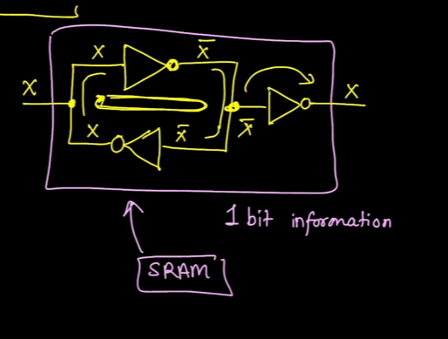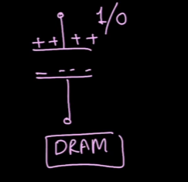
- This is how 1 bit is stored in memory in SRAM secondary memory (1 TB mem) using 3 NOT (inverter).
- And this is how DRAM main memory RAM (8/16 GB ram) is stored using a capacitor.

          - PC and branching: -
- Here we PC (program counter) provides the CPU from which place the data is to be fetched and it increments in a linear manner. If we have instruction size of 4 bytes it increments 0,4,8 way if size if 2 then 0,2,4 etc.
- So, if lets say it is of 4 bytes and it is going 1,4,8,24. Here it jumped from 8 to 24, this is known as branching or jumping.

          - Make file:-
- Make file contains the following part ; “riscv64-unknown-elf-gcc -O0 -ggdb -nostdlib -march=rv32i -mabi=ilp32 -W,-Tmain.ld main.s -o main.elf”.
  - riscv64-unknown-elf-gcc:- is our compiler.
  - -O0: - means 0 or no optimaization.
  - -ggdb: - means gdb enabled.
  - -nostdlib: - this means that we are not using any std libs.
  - -march=rv32i: - it mentions the architecture of our system
  - -mabi=ilp32: - it means that compiler needs to generate 32 bit set instruction set.
  - -W,-Tmain.ld: - linker script to dictate the code placement in the memory where Tmain.ld is custom linker script.
  - Main.s: - file provided it should be in .s format.
  - Main.elf: - file name generated after this compilation.
- When we run a code we can see that the data is stored in 32 bit regs staring from “zero (x0), ra (x1), sp (x2) … t6(x31)”. Here we can see that these regs are not named from x0 to x31 because they are known as ABI (Application Binary Interface) regs.
- PC (program counter) is not included in ABIs. The 32 bit regs + PC are called GPR (General Purpose Regs).
- When we run the code the other registers used are called SRFs / CFRs (Special/Configurable Function Registers).

          - Linker Script: -
- Linker script helps to control the placement of code.
- When we execute the code, first we use gcc for the compilation of the code for the code to convert into assembly language. This asm code is then with the help of linker script is converted to machine code.
- When we don’t provide a linker script (ls) during the compilation, then the machine wont know where to start the code even though we have provided start in the code. Here every system has a linker script and will use the default linker script when we don’t mention any linker script.
- For this we will use .globl start. This will provide the machine to understand where to start the code. Here we used ”.globl”because anything which starts from “.” Are know as directors which guides the assembler.
- Here after this when we try to run the code with gdb, we will not be able to see anything so press “ctrl+c” and then you will able to see proper gdb screen, but still wont see the code running as it is using default linker script, and also before running any code the system runs a little ROM code and then access RAM where our code is placed. Even after reaching our start position it will still fail to run the program.
- This is because the system does not know what to do with this cmd and where to jump after this cmd and so on. Because the system will be using machine code directly without knowing what to do.
- The main difference between elf and binary file is that, bin files have only machine code while the elf contains many sections along with the bin code which helps the machine to understand what to do in the program.
- To solve this problem we need to provide a linker script to hwlp the spu to locate the Ram location, length of the program and different sections.
  - How to make a linker script?
    - Create a file with extension of .ld.
MEMORY
{
RAM : ORIGIN = 0X80000000, LENGTH =4k
}

SECTIONS
{
.text: {
*(.text*) // (.shivam)
} > RAM
}
    - Here MEMORY and SECTIONS are the commands, RAM and LENGTH are attributes.
    - In sections, we say that all the files related to *(.text*) should be placed in the .text section. We can also modify that instead of all the .shivam files whould be placed inside the text section. For that we need to mention in the asm code “.section .shivam (then next line)_start (next line with tab) code”. This code will work well and place all the sections containing .shivam inside text section in the elf file.
- Use memory-mapped I/O:
When you need high-speed data transfer to a device and simplicity in programming.
- Use non-memory mapped I/O:
When you need precise control over a device's operations or when dealing with legacy hardware that doesn't support memory-mapped I/O.

          - Print and scan family in C/C++:-
- Printf and scanf will not be displayed.
- Fprintf: -
  - Prints formateed output to a file stream.
  - Eg: -
FILE *file = fopen(“output.txt”, “w”);
If(file){
Fprintf(file, “File content: %d, %f \n”, 42, 3.14);
Fclose(file);
}
- Fscanf: -
  - Reads formatted input form a file stream.
  - Eg: -
FILE *file = fopen(“input.txt”, “r”);
Fscanf(file, “%d”, &num);
- Sprint: -
  - Formats and store the result in a string buffer without bound checking.
  - Bound checking means If the output exceeds the size of the buffer, it causes a buffer overflow, potentially leading to security vulnerabilities or program crashes.
  - So if using sprint if the size is greater than buf then it will crash or overwrite the program but in snprintf it will only consider the size stirng and will neglect the other data without crashing the program.
Char buf[100];
Sprint(buf, “Name: %s, Age: %d”, “Alice”, 30);
- Snprintf(): -
  - Formats and stroe the result in a string buffer with bound checking.
  - Here when we want to write to buffer from one place and also manage the buffer size we will use snprintf.
  - Snprintf(buffer,sizeof(buffer),FORMAT,data), here buffer is the buffer where you want to store the data, then its size, FORMAT means in which format the data will to be stored, data is the data we want to store.
  - Eg:-
Struct Person{
Char st[]=”Shivam”, int b = 12, double = “23.3”;
}
Char buf[1024] = {0},
Int pos =0;
Pos += snprintf(buf,sizeof(buf),”%s %d %lf”,Person);
  - Here we pos is used to maintain the size of buf and also if we want to append in buf then we need the next empty space so. And also we can increase the pos size like this and also this snprintf does not print on the screen, if we want to print on the screen, we need to use printf.
- Sscanf(): -
  - Here when we have some data in a buffer or from some place, we just use sscanf to get the data from that place without picking separately.
  - Eg: -
Struct Person {
Char name[1024]; unsigned int rollno; double percentage;
}

Int main(){
Person student = {0};
Char *data = “Paul 101 68.5””;
Sscanf(data, “%s %d %lf”, student.name, &student.rollno, &student.percentage);
Printf(“name = %s , roll_no = %d, percentage=%0.2lf”, student.name, student.rollno,student.percentage);
Return 0;
}
  - Here we need to make sure that format should match like if the data is in “[Shivam,1,23.3]” then format should be like this “[%s,%d,%lf]”.
  - In this part Sscanf(data, “%s %d %lf”, student.name, &student.rollno, &student.percentage); I have given & to only roolno and percentage because name is already in pinter due to char array. So need to mention & in the name but needs in other as they are not array.
- Vprintf: -
  - Variant of printf that takes a va_list. Usefule for custom functions with variable arguments.
  - Eg: -
Void customprint(const char *fo, …){
Va_list args;
Va_start(args, format);
Vprintf(format, args);
Va_end(args);
}
Customprint(“Hello %s\n”, “world”);
- Vscanf: -
  - Variant of scanf that takes va_list.
  - Eg: -
Va_list args; va_start(args, format);
Vscanf(format, args);
- Vfprintf: -
  - Like vprintf, but output to a file stream.
Vfprintf(file, format, args);
- Vfscanf: -
  - Like fscanf, but uses va_list.
  - Eg: -
FILE *file = fopen(“inout.txt”, “r”);
Va_list args; va_start(args, format);
Vfscanf(file, format, args);
- Vsprintf: -
  - Like sprint, but takes a va_list.
Char buf[100];
Va_list args; va_start(args, format);
Vsprintf(buf, format, args);
Va_end(args);
- Vsnprintf: -
  - Like snprintf, but takes a va_list.
Vsnprintf(buf, sizeof(buf), format, args);
- Vsscanf: -
  - Like sscanf, but uses a va_list.
  - Vsscanf(data, format, args);

          - String copy and memory copy: -
- Strcpy: -
  - Copies onw null-terminated string to another. It does not check for buffer overflow.
Char source[] = “hello, world”;
Char des[50];
Strcpy(des, source);
- Strncpy: -
  - Safer alternative to strcpy. Copies up to a specidied number of characters. Ensure the sedtination is null-terminated manually if the source is longer than the limit.
Strncpy(des, source, sizeof(des)-1);
Des[sizeof(des)-1] = ‘\0’;
- Strncpy_s: -
  - Similar to strncpu, nit includes additional safety checks.
Strncpy_s(des, sizeof(des), source, n);
- Memcpy: -
  - If you need to copy raw data from one buffer to another we use memcpy or memmove.
  - It does not check for overlap between source and des.
Memcpy(des, source, strlen(source)+1);
- Memmove: -
  - Similar to memcpy but safe for overlapping mem regions.
  - Memmove(source, source+3, strlen(source) -2);
  - This will overlap the mem region.

          - Multi-threading: -
- Thread creation and joining.
- Mutex locking and unlocking and trylock and unlock.
- Condition variables and signaling in multithreading.
- To create barrier that this much threads needed to start this func so that those threads run parallelly doing same thing.

Pthread_mutex_t mutexFuel;
Pthread_cond_t condFuel;
Int fuel=0;
Void* routine(void* argv[]){
//code
*(*void or *int) res = data;
Return res;
}
Int main(){
Pthread_t t[3]; //3 thread creation

}

*******************Bootloader development for ARM cortex STM32Fx Microcontroller
- Bootloader:-
- It is nothing buyt a small piece of code stored in the MCU flash or ROM to act as an application loader as well as a mechanism to update the applications whenever required.
- Some micro controller comes with in circuit debugger like STMF series, TI and many more.
- SO the mcu which does not have in circuit debugger, it will always use bootloader to update application or binary when we flashed it with new program. Eg:- arduino. It will always use bootloader to update binaries.
- If there is in circuit debugger then it will use that circuit instead of bootloader. Eg;- STM has cuitcit so it will use that instead of bootloader to update binaries.

          - Memory organization: -
- Main Memory or Internal flash mem also called as Embedded flash (512kb): -
  - Begins @ 0x0800_0000.
  - Ends @ 0x0807_FFFF.
  - Used to store ur app code and vector table ("vector table" in a microcontroller is a data structure that stores the memory addresses of specific interrupt service routines (ISRs)) (“switch table" refers to a data structure within the kernel that acts as a lookup table for device drivers) and ROM of the program.
  - Non-volatile.
  - Ther are 8 sub section in this memory from s0 to s3 (16kb), s4 (64kb) and s5 to s7 (128kb). So when we flash the code, it will start flashing or occupying the s0 section and will move towards s7.
- Internal SRAM1 (112kb): -
  - Begins @ 0x2000_0000.
  - Ends @ 0x2001_BFFF.
  - Used to store ur app global data and static variables.
  - Also used for stack and heap purpose.
  - Volatile.
  - Also execute code from this mem.
- Internal SRAM2 (16kb): -
  - Begins @ 0x2001_C000.
  - Ends @ 0x2001_FFFF.
  - Used to store ur app global data, static variables.
  - Also can be used for stack and heap purpose.
  - Volatile.
  - You can execute code from this memory.
- System mem (ROM) (30kb): -
  - Begins @ 0x1FFF_0000.
  - Ends @ 0x1FFF_77FF.
  - Store bootloader in this mem.
  - By default mcu will not execute any code from this mem but you can config mcu to boot or execute bootloader from this mem. This means that even if you power up the controller it will not execute any code as it will not use bootloader always when power up. So to execute from this section we need to config some boot pins to execute this code.
- OPT (One Time Programmable) mem (528b): -
  - To store controller name and number or signature.
- Backup RAM (4kb): -

          - Reset sequences for a mcu
- When you reset the mcu the PC (program counter) of the processor is loaded with the value 0x0000_0000.
- Then processor reads the value @ mem location 0x0000_0000 into MSP (Main Stack Pointer).
MSP = value@0x0000_0000
That means, processor first initializes the Stack pointer regs.
- After that, processor reads the values @ mem location 0x0000_0004 into PC.
- PC jumps to reset handler.
- A reset handler is just a C or assembly function written by you to carry out any init required.
- From reset handler you call your main() func of the app.
- But as we see the main mem starts from location 0x0800_0000 and in there the user flashed code is stored so mcu should instead of 0x0000_0000 should go look for or start from 0x0800_0000.
- In mcu, whether you look in 0x0000_0000 or 0x0800_0000 they both holds the same info. This is because of “memory aliasing”.
          - Memory aliasing is a way by which the code store on location 0x0800_0000 is mapped to location 0x0000_0000 and some of the other location are also aliased.
- It is used to map memory of some location to another location.

          - Boot loader overview: -
- When the core is reset, the user has the opportunity to direct the core to execute the ROM boot loader or the application in flash mem by using any GPIO signal in ports A-H as configured in the Boot config (BOOTCFG) reg.

